**VISVESVARAYA TECHNOLOGICAL UNIVERSITY**

**“JnanaSangama”, Belgaum -590014, Karnataka.**



**LAB REPORT**

**on**

**Object Oriented Java Programming (23CS3PCOOJ)**

***Submitted by***

**Kishore Chandra N (1BM23CS154)**

***in partial fulfillment for the award of the degree of***

**BACHELOR OF ENGINEERING**

***in***

**COMPUTER SCIENCE AND ENGINEERING**



**B.M.S. COLLEGE OF ENGINEERING**

**(Autonomous Institution under VTU)**

**BENGALURU-560019**

**Sep-2024 to Jan-2025**

**B.M.S. College of Engineering,**

**Bull Temple Road, Bangalore 560019**

(Affiliated To Visvesvaraya Technological University, Belgaum)

**Department of Computer Science and Engineering**



**CERTIFICATE**

This is to certify that the Lab work entitled “Object Oriented Java Programming (23CS3PCOOJ)” carried out by **Kishore Chandra N (1BM23CS154),** who is bonafide student of **B.M.S. College of Engineering.** It is in partial fulfillment for the award of **Bachelor of Engineering in Computer Science and Engineering** of the Visvesvaraya Technological University, Belgaum. The Lab report has been approved as it satisfies the academic requirements in respect of an Object Oriented Java Programming (23CS3PCOOJ) work prescribed for the said degree.

|  |  |
| --- | --- |
| Ambuja K  Assistant Professor  Department of CSE, BMSCE | Dr. Jyothi S Nayak  Professor & HOD  Department of CSE, BMSCE |

**Index**

|  |  |  |  |
| --- | --- | --- | --- |
| **Sl.**  **No.** | **Date** | **Experiment Title** | **Page No.** |
| 1 | 30-9-2024 | **Quadratic Equations** | 4 |
| 2 | 7-10-2024 | **SGPA Calculator** | 7 |
| 3 | 14-10-2024 | **Book Details** | 10 |
| 4 | 21-10-2024 | **Area of Figures** | 13 |
| 5 | 28-10-2024 | **Bank Account Details** | 16 |
| 6 | 11-11-2024 | **SEE and CIE Marks Displayer** | 23 |
| 7 | 28-11-2024 | **Exception Handling** | 28 |
| 8 | 28-11-2024 | **Threads** | 32 |
| 9 | 28-11-2024 | **Divisor App** | 35 |
| 10 | 28-11-2024 | **Inter Process Communication and Deadlock** | 40 |

Github Link: https://github.com/Kishore868/OOJ-Lab-Programs

**Program 1**

Implement Quadratic Equation

Algorithm:

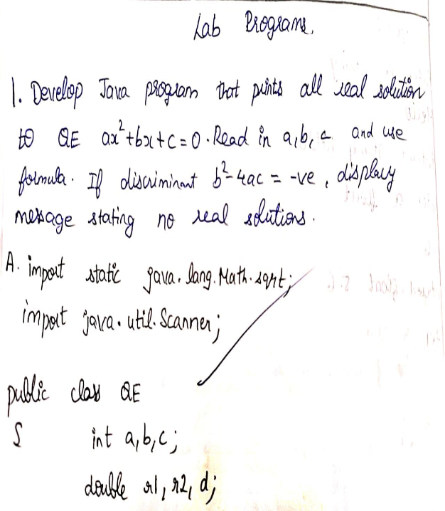 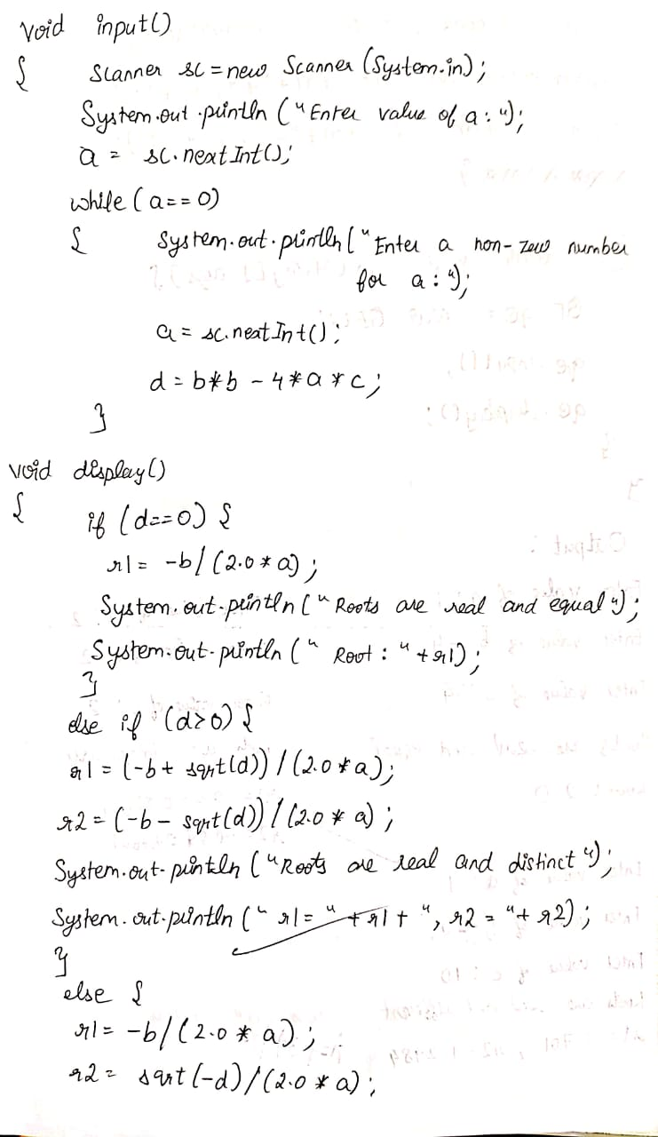

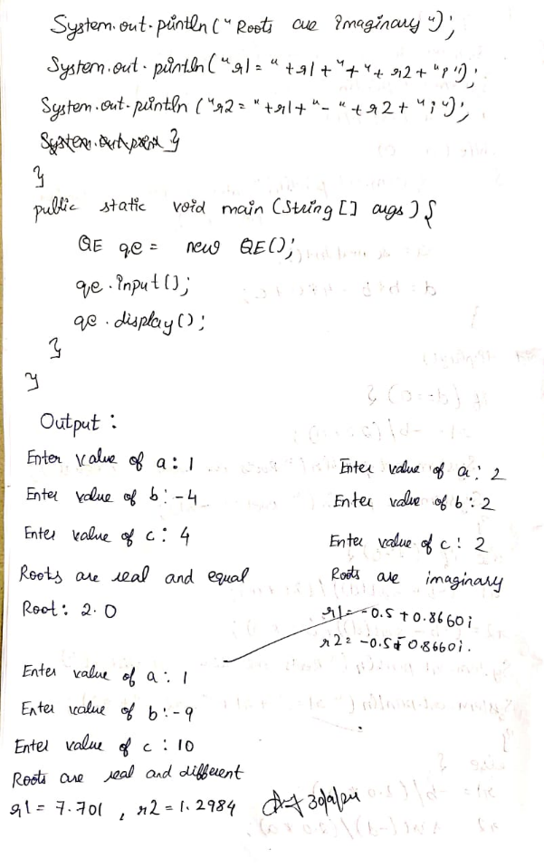

Code:

import static java.lang.Math.sqrt;

import java.util.Scanner;

class QE {

int a, b, c;

double r1, r2, d;

void input() {

Scanner sc = new Scanner(System.in);

System.out.print("Enter value of a: ");

a = sc.nextInt();

while (a == 0) {

System.out.println("Enter a non-zero number for a:");

a = sc.nextInt();

}

System.out.print("Enter value of b: ");

b = sc.nextInt();

System.out.print("Enter value of c: ");

c = sc.nextInt();

d = b * b - 4 * a * c;

}

void display() {

if (d == 0) {

r1 = -b / (2.0 * a);

System.out.println("Roots are real and equal");

System.out.println("Root: " + r1);

System.out.println("1BM23CS154");

System.out.println("Kishore Chandra N");

} else if (d > 0) {

r1 = (-b + sqrt(d)) / (2.0 * a);

r2 = (-b - sqrt(d)) / (2.0 * a);

System.out.println("Roots are real and different");

System.out.println("r1 = " + r1 + ", r2 = " + r2);

System.out.println("1BM23CS154");

System.out.println("Kishore Chandra N");

} else {

r1 = -b / (2.0 * a);

r2 = sqrt(-d) / (2.0 * a);

System.out.println("Roots are imaginary");

System.out.println("r1 = " + r1 + " + " + r2 + "i");

System.out.println("r2 = " + r1 + " - " + r2 + "i");

System.out.println("1BM23CS154");

System.out.println("Kishore Chandra N");

}

}

public static void main(String[] args) {

QE qe = new QE();

qe.input();

qe.display();

}

}

Output:

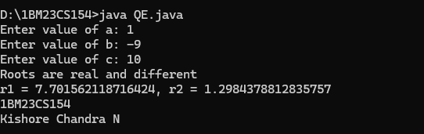

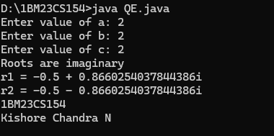

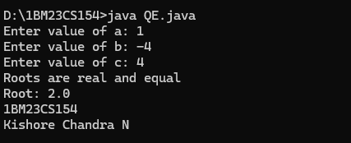

**Program 2**

Develop a Java program to create a class Student with members usn, name, an array credits and an array marks.

Include methods to accept and display details and a method to calculate SGPA of a student.

Algorithm:

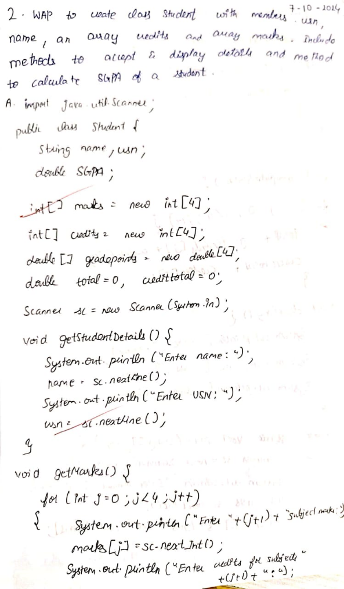 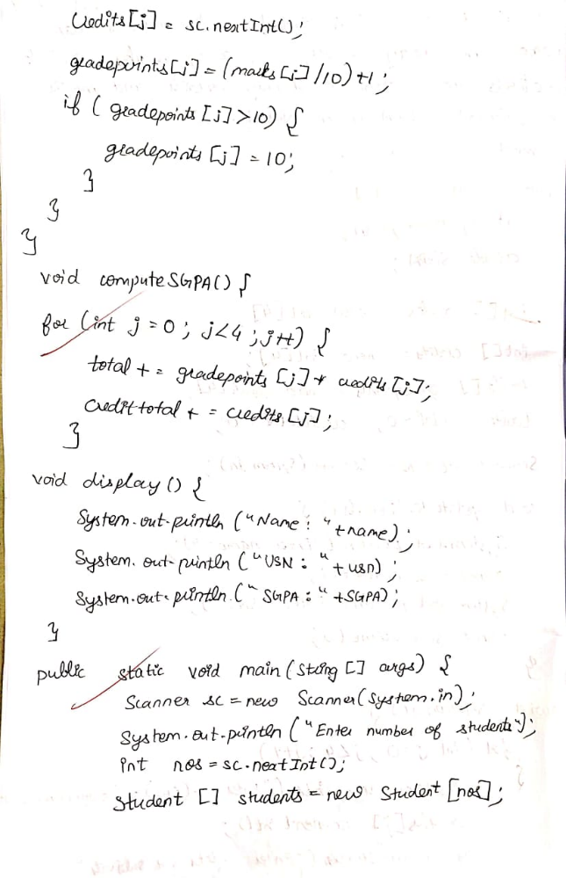

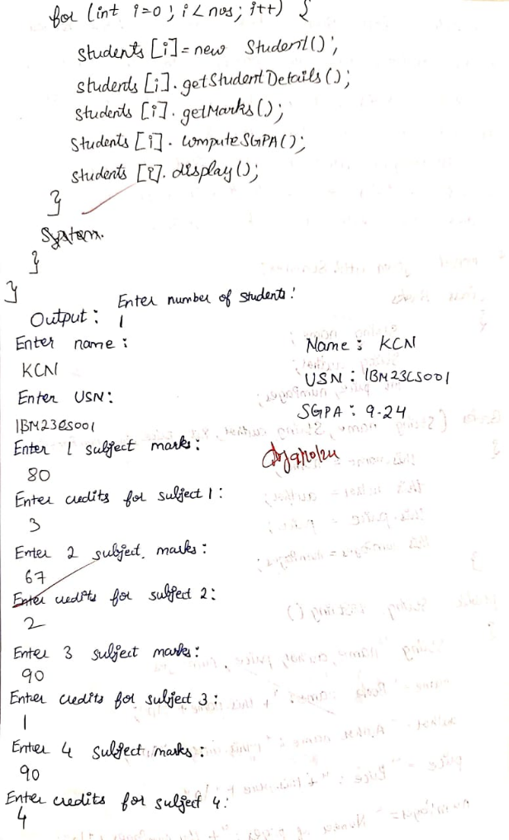

Code:

import java.util.Scanner;

public class Student {

String name, usn;

double SGPA;

int[] marks = new int[4];

int[] credits = new int[4];

double[] gradepoints = new double[4];

double total = 0, credittotal = 0;

Scanner sc = new Scanner(System.in);

void getStudentDetails() {

System.out.println("Enter name:");

name = sc.nextLine();

System.out.println("Enter USN:");

usn = sc.nextLine();

}

void getMarks() {

for (int j = 0; j < 4; j++) {

System.out.println("Enter " + (j + 1) + " subject marks:");

marks[j] = sc.nextInt();

System.out.println("Enter credits for subject " + (j + 1) + ":");

credits[j] = sc.nextInt();

gradepoints[j] = (marks[j] / 10.0) + 1;

if (gradepoints[j] > 10) {

gradepoints[j] = 10;

}

}

sc.nextLine();

}

void computeSGPA() {

total = 0;

credittotal = 0;

for (int j = 0; j < 4; j++) {

total += gradepoints[j] * credits[j];

credittotal += credits[j];

}

SGPA = total / credittotal;

}

void display() {

System.out.println("Name: " + name);

System.out.println("USN: " + usn);

System.out.println("SGPA: " + SGPA);

}

public static void main(String[] args) {

Scanner sc = new Scanner(System.in);

System.out.println("Enter number of students:");

int numberOfStudents = sc.nextInt();

sc.nextLine();

Student[] students = new Student[numberOfStudents];

for (int i = 0; i < numberOfStudents; i++) {

students[i] = new Student();

students[i].getStudentDetails();

students[i].getMarks();

students[i].computeSGPA();

students[i].display();

}

System.out.println("1BM23CS154 Kishore Chandra");

}

}

Output:

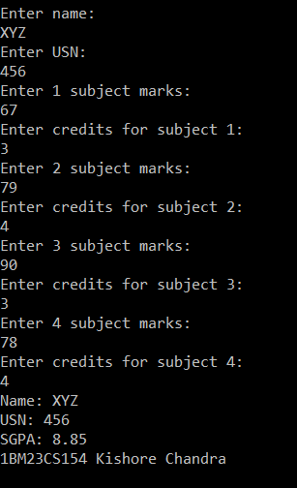 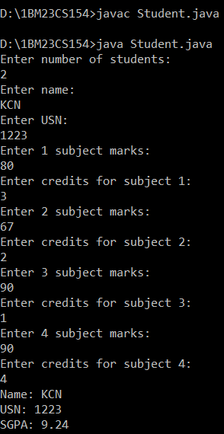

**Program 3**

Create a class Book which contains four members: name, author, price, num_pages. Include a constructor to set the values for the members. Include methods to set and get the details of the objects. Include a toString( ) method that could display the complete details of the book. Develop a Java program to create n book objects.

Algorithm:

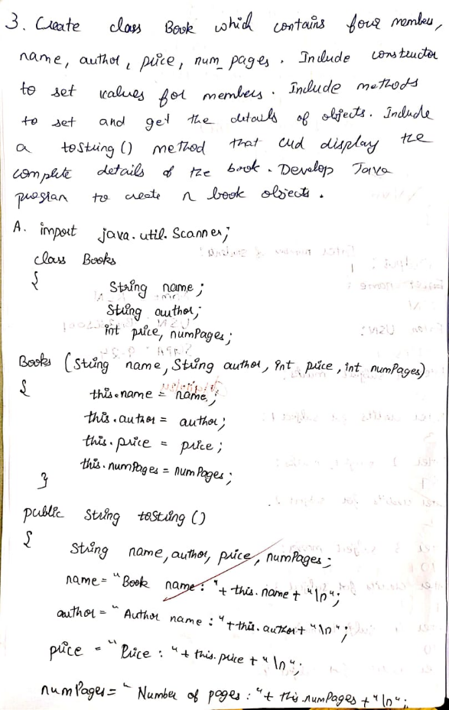 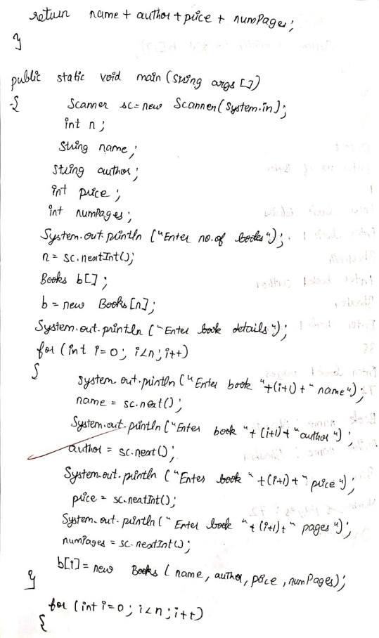

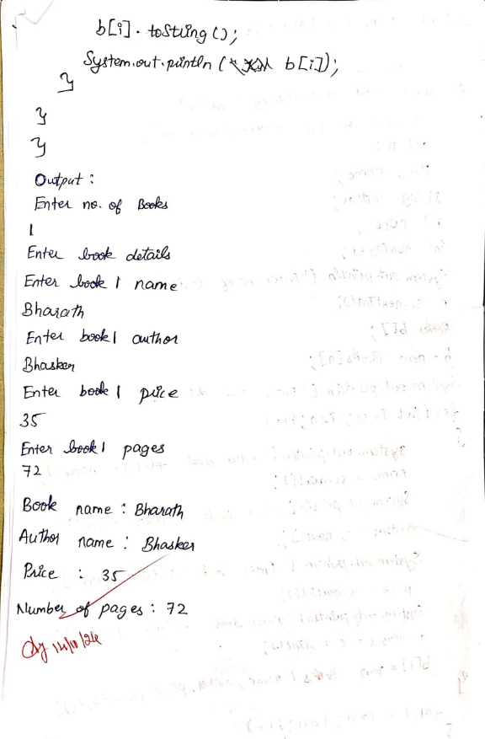

Code:

import java.util.Scanner;

class Books

{

String name;

String author;

int price,numPages;

Books(String name,String author,int price,int numPages)

{ this.name = name;

this.author = author;

this.price = price;

this.numPages = numPages;

}

public String toString()

{

String name, author, price, numPages;

name = "Book name: " + this.name + "\n";

author = "Author name: " + this.author + "\n";

price = "Price: " + this.price + "\n";

numPages = "Number of pages: " + this.numPages + "\n";

return name + author + price + numPages;

}

public static void main(String args[])

{

Scanner sc=new Scanner(System.in);

int n;

String name;

String author;

int price;

int numPages;

System.out.println("Enter no. of books");

n=sc.nextInt();

Books b[];

b=new Books[n];

System.out.println("Enter book details");

for(int i=0;i<n;i++)

{

System.out.println("Enter book "+(i+1)+" name");

name=sc.next();

System.out.println("Enter book "+(i+1)+" author");

author=sc.next();

System.out.println("Enter book "+(i+1)+" price");

price=sc.nextInt();

System.out.println("Enter book "+(i+1)+" pages");

numPages=sc.nextInt();

b[i]=new Books(name,author,price,numPages);

}

for(int i=0;i<n;i++)

{

b[i].toString();

System.out.println(b[i]);

}

System.out.println("Kishore Chandra N");

System.out.println("1BM23CS154");

}

}

Output:

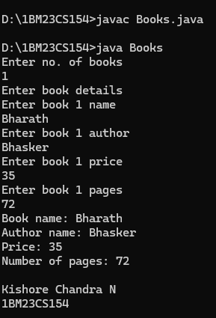

**Program 4**

Develop a Java program to create an abstract class named Shape that contains two integers and an empty methodnamed printArea( ). Provide three classes named Rectangle, Triangle and Circle such that each one of theclasses extends the class Shape. Each one of the classes contain only the method printArea( ) that prints the area of the given shape.

Algorithm:

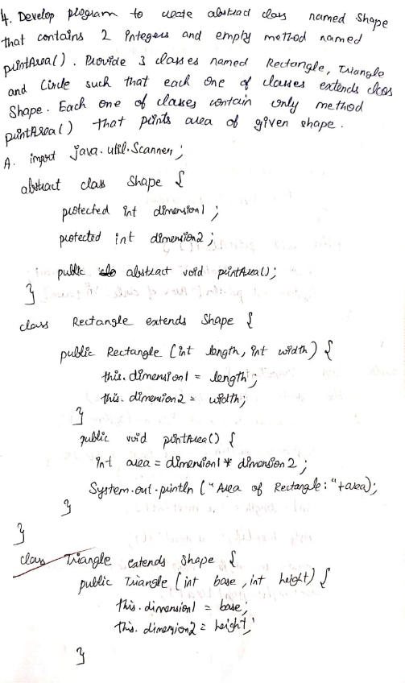 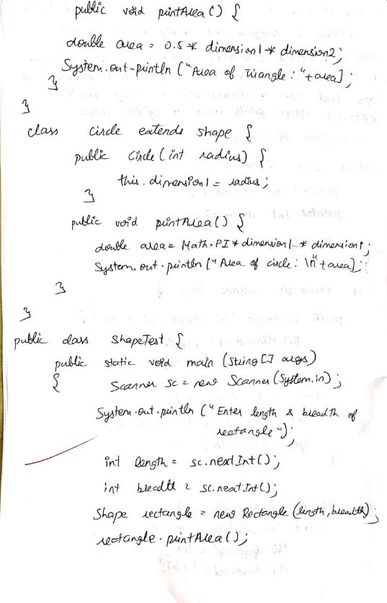

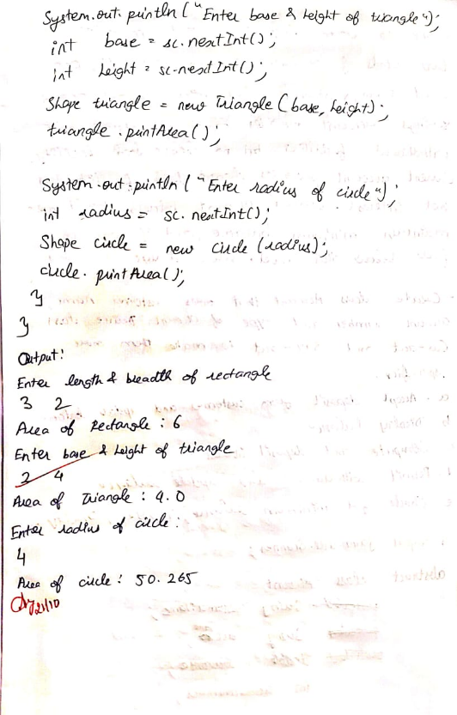

Code:

import java.util.Scanner;

abstract class Shape {

protected int dimension1;

protected int dimension2;

public abstract void printArea();

}

class Rectangle extends Shape {

public Rectangle(int length, int width) {

this.dimension1 = length;

this.dimension2 = width;

}

public void printArea() {

int area = dimension1 * dimension2;

System.out.println("Area of Rectangle: " + area);

}

}

class Triangle extends Shape {

public Triangle(int base, int height) {

this.dimension1 = base;

this.dimension2 = height;

}

public void printArea() {

double area = 0.5 * dimension1 * dimension2;

System.out.println("Area of Triangle: " + area);

}

}

class Circle extends Shape {

public Circle(int radius) {

this.dimension1 = radius;

}

public void printArea() {

double area = Math.PI * dimension1 * dimension1;

System.out.println("Area of Circle: \n" + area);

System.out.println("1BM23CS154 Kishore Chandra");

}

}

public class ShapeTest {

public static void main(String[] args) {

Scanner scanner = new Scanner(System.in);

System.out.print("Enter length of rectangle: ");

int length = scanner.nextInt();

System.out.print("Enter width of rectangle: ");

int width = scanner.nextInt();

Shape rectangle = new Rectangle(length, width);

rectangle.printArea();

System.out.print("Enter base of triangle: ");

int base = scanner.nextInt();

System.out.print("Enter height of triangle: ");

int height = scanner.nextInt();

Shape triangle = new Triangle(base, height);

triangle.printArea();

System.out.print("Enter radius of circle: ");

int radius = scanner.nextInt();

Shape circle = new Circle(radius);

circle.printArea();

scanner.close();

}

}

Output:

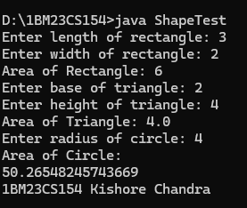

**Program 5**

Develop a Java program to create a class Bank that maintains two kinds of account for its customers, one called savings account and the other current account. The savings account provides compound interest and withdrawal facilities but no cheque book facility. The current account provides cheque book facility but no interest. Current account holders should also maintain a minimum balance and if the balance falls below this level, a service charge is imposed. Create a class Account that stores customer name, account number and type of account. From this derive the classes Cur-acct and Sav-acct to make them more specific to their requirements. Include the necessary methods in order to achieve the following tasks:

a) Accept deposit from customer and update

the balance.

b) Display the balance.

c) Compute and deposit interest

d) Permit withdrawal and update the balance

Check for the minimum balance, impose penalty if

necessary and update the balance.

Algorithm:

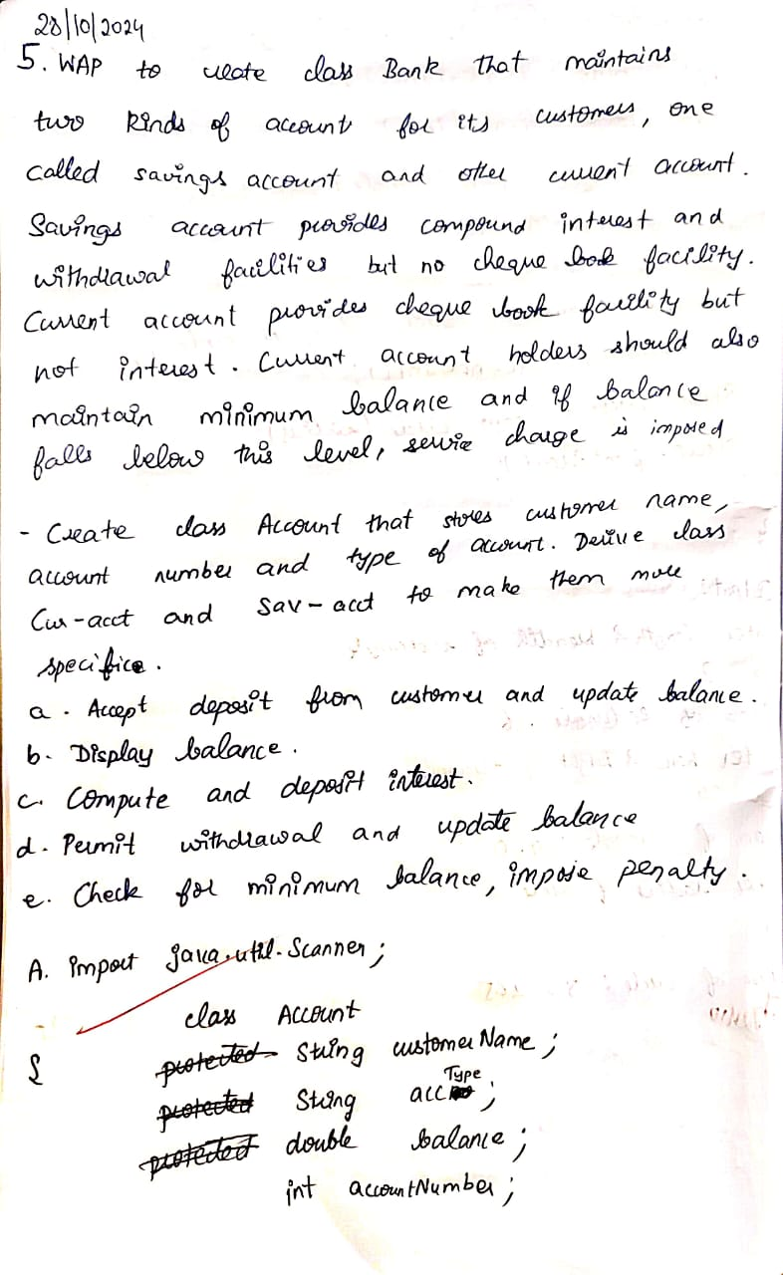 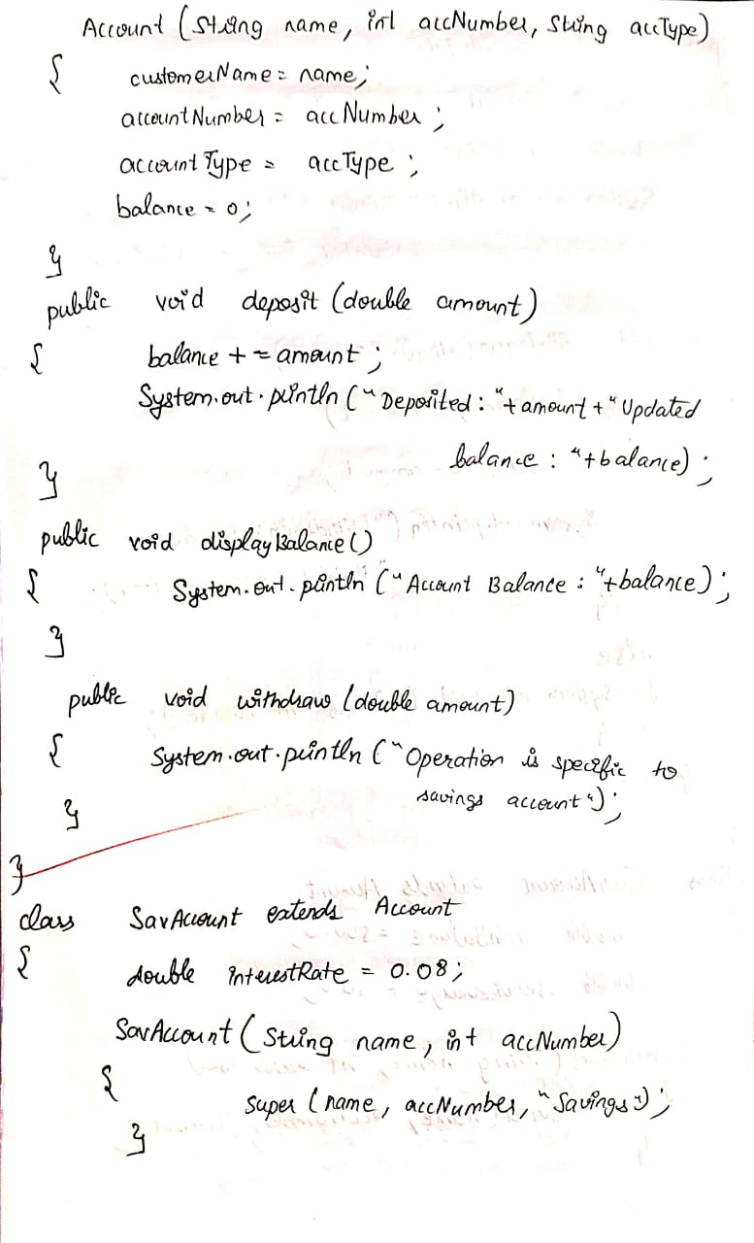

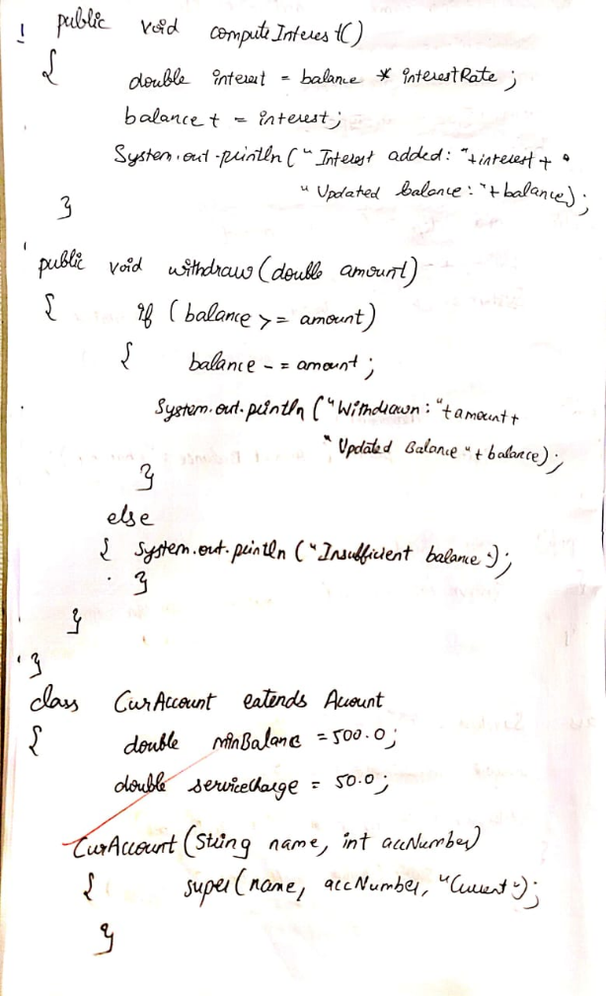 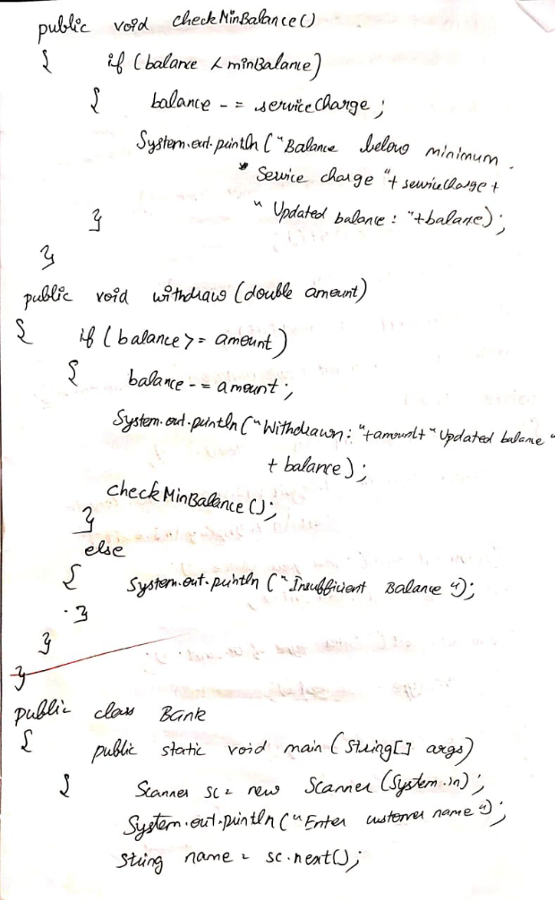

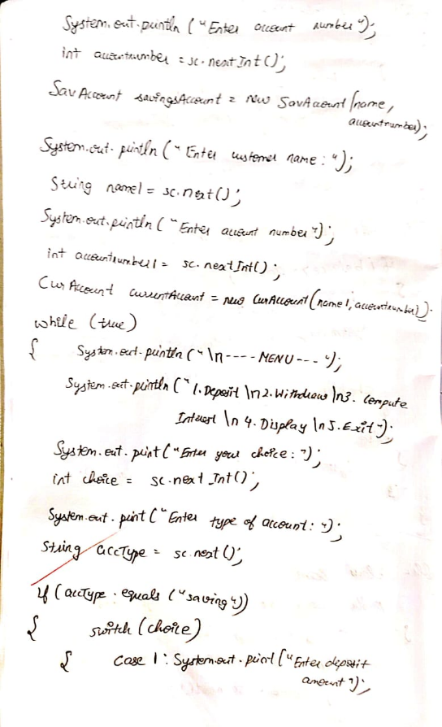 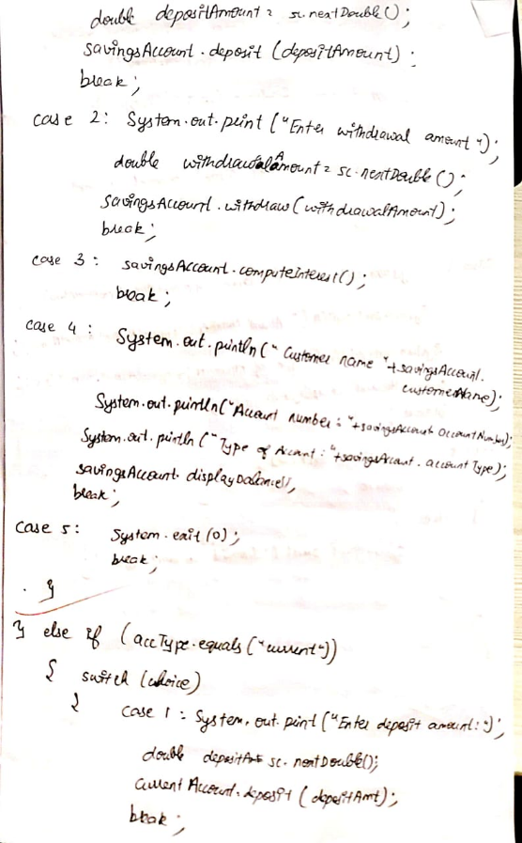

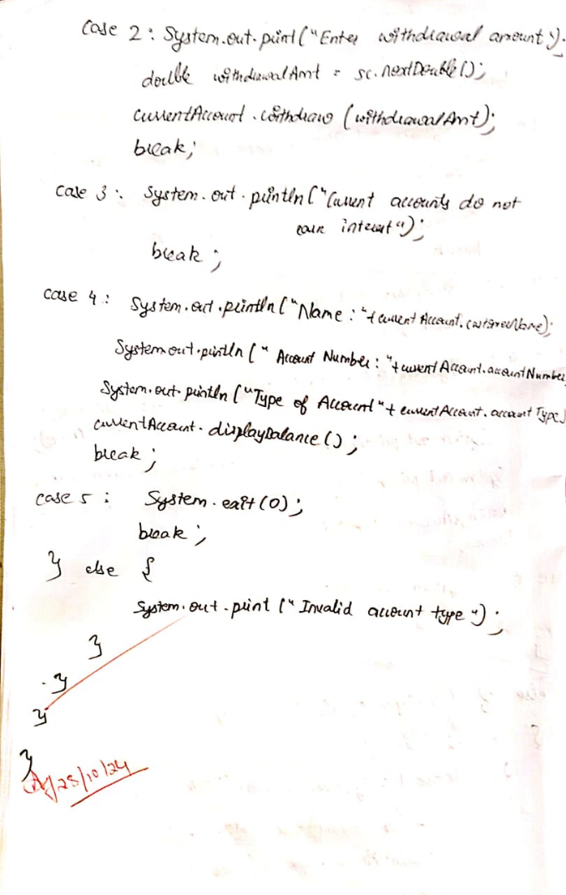 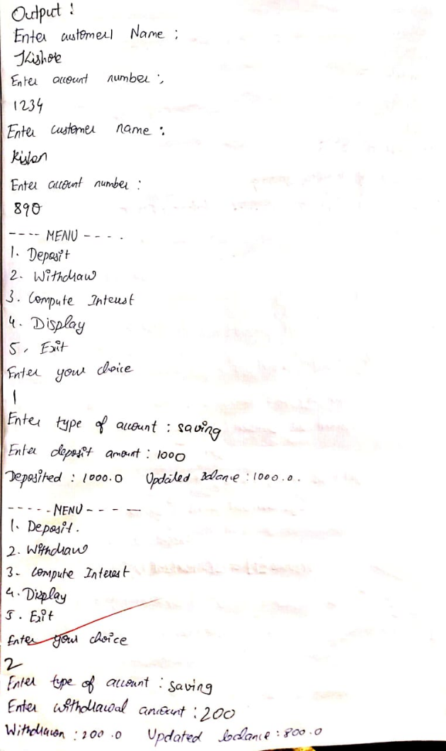

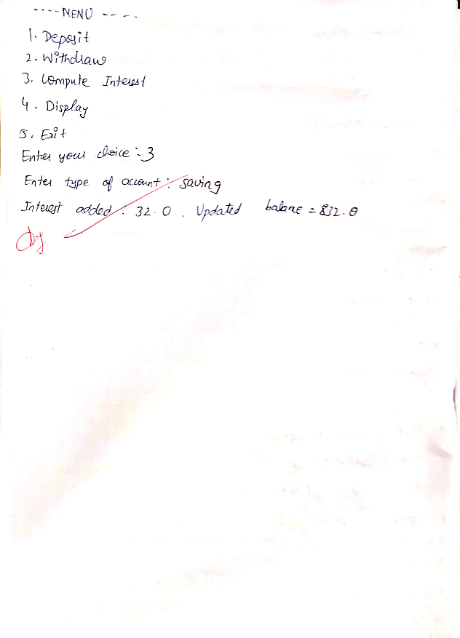

Code:

import java.util.Scanner;

class Account {

String customerName;

int accountNumber;

String accountType;

double balance;

Account(String name, int accNumber, String accType) {

customerName = name;

accountNumber = accNumber;

accountType = accType;

balance = 0;

}

public void deposit(double amount) {

balance += amount;

System.out.println("Deposited: " + amount + ". Updated balance: " + balance);

}

public void displayBalance() {

System.out.println("Account Balance: " + balance);

}

public void withdraw(double amount) {

System.out.println("This operation is specific to account type.");

}

}

class SavAccount extends Account {

double interestRate = 0.04; // 4% annual interest rate

SavAccount(String name, int accNumber) {

super(name, accNumber, "Savings");

}

public void computeInterest() {

double interest = balance * interestRate;

balance += interest;

System.out.println("Interest added: " + interest + ". Updated balance: " + balance);

}

public void withdraw(double amount) {

if (balance >= amount) {

balance -= amount;

System.out.println("Withdrawn: " + amount + ". Updated balance: " + balance);

} else {

System.out.println("Insufficient balance.");

}

}

}

class CurAccount extends Account {

double minBalance = 500.0;

double serviceCharge = 50.0;

CurAccount(String name, int accNumber) {

super(name, accNumber, "Current");

}

public void checkMinBalance() {

if (balance < minBalance) {

balance -= serviceCharge;

System.out.println("Balance below minimum. Service charge imposed: " + serviceCharge + ". Updated balance: " + balance);

}

}

public void withdraw(double amount) {

if (balance >= amount) {

balance -= amount;

System.out.println("Withdrawn: " + amount + ". Updated balance: " + balance);

checkMinBalance();

} else {

System.out.println("Insufficient balance.");

}

}

}

public class Bank {

public static void main(String[] args) {

Scanner sc = new Scanner(System.in);

System.out.println("Enter customer name:");

String name=sc.next();

System.out.println("Enter account number:");

int accountnumber=sc.nextInt();

SavAccount savingsAccount = new SavAccount(name, accountnumber);

System.out.println("Enter customer name:");

String name1=sc.next();

System.out.println("Enter account number:");

int accountnumber1=sc.nextInt();

CurAccount currentAccount = new CurAccount(name1, accountnumber1);

while (true) {

System.out.println("\n-----MENU-----");

System.out.println("1. Deposit\n2. Withdraw\n3. Compute Interest for Savings Account\n4. Display Account Details\n5. Exit");

System.out.print("Enter your choice: ");

int choice = sc.nextInt();

System.out.print("Enter the type of account (saving/current): ");

String accType = sc.next();

if (accType.equals("saving")) {

switch (choice) {

case 1:

System.out.print("Enter the deposit amount: ");

double depositAmount = sc.nextDouble();

savingsAccount.deposit(depositAmount);

break;

case 2:

System.out.print("Enter the withdrawal amount: ");

double withdrawalAmount = sc.nextDouble();

savingsAccount.withdraw(withdrawalAmount);

break;

case 3:

savingsAccount.computeInterest();

break;

case 4:

System.out.println("Customer name: " + savingsAccount.customerName);

System.out.println("Account number: " + savingsAccount.accountNumber);

System.out.println("Type of Account: " + savingsAccount.accountType);

savingsAccount.displayBalance();

break;

case 5:

System.exit(0);

break;

default:

System.out.println("Invalid choice.");

}

} else if (accType.equals("current")) {

switch (choice) {

case 1:

System.out.print("Enter the deposit amount: ");

double depositAmount = sc.nextDouble();

currentAccount.deposit(depositAmount);

break;

case 2:

System.out.print("Enter the withdrawal amount: ");

double withdrawalAmount = sc.nextDouble();

currentAccount.withdraw(withdrawalAmount);

break;

case 3:

System.out.println("Current accounts do not earn interest.");

break;

case 4:

System.out.println("Customer name: " + currentAccount.customerName);

System.out.println("Account number: " + currentAccount.accountNumber);

System.out.println("Type of Account: " + currentAccount.accountType);

currentAccount.displayBalance();

break;

case 5:

System.exit(0);

break;

default:

System.out.println("Invalid choice.");

}

} else {

System.out.println("Invalid account type.");

}

}

}

}

Output:

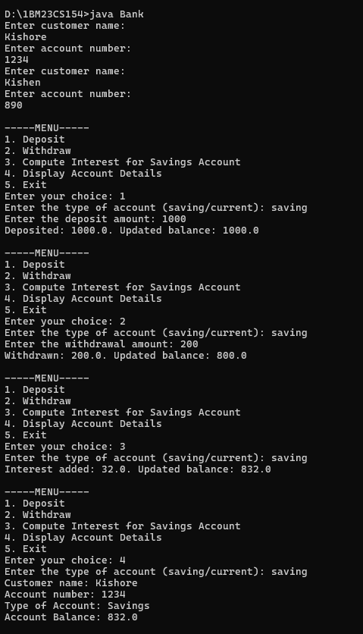 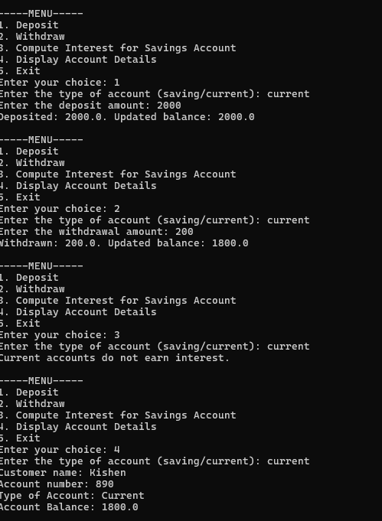

**Program 6**

Create a package CIE which has two classes- Student and Internals. The class Personal has members like usn, name, sem. The class internals has an array that stores the internal marks scored in five courses of the current semester of the student. Create another package SEE which has the class External which is a derived class of Student. This class has an array that stores the SEE marks scored in five courses of the current semester of the student. Import the two packages in a file that declares the final marks of n students in all five courses.

Algorithm:

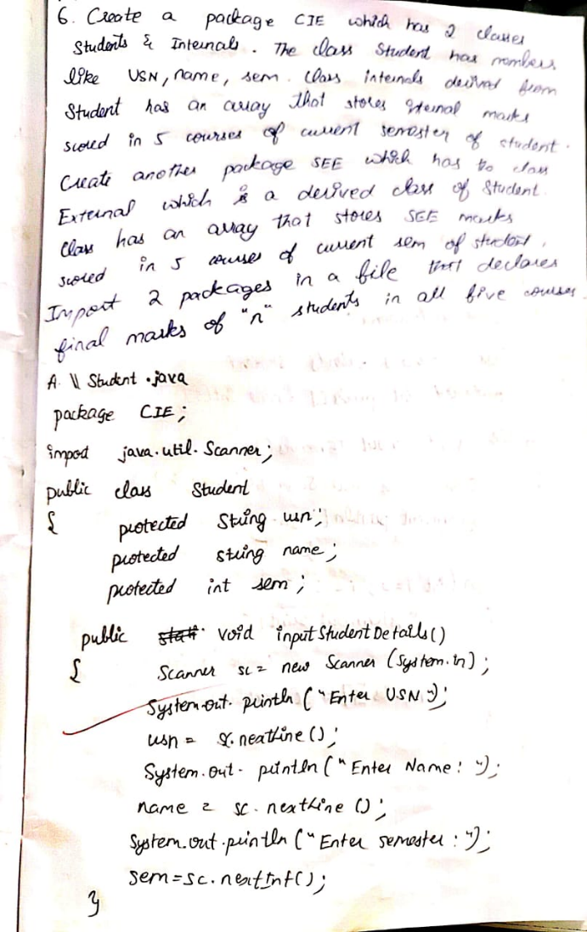 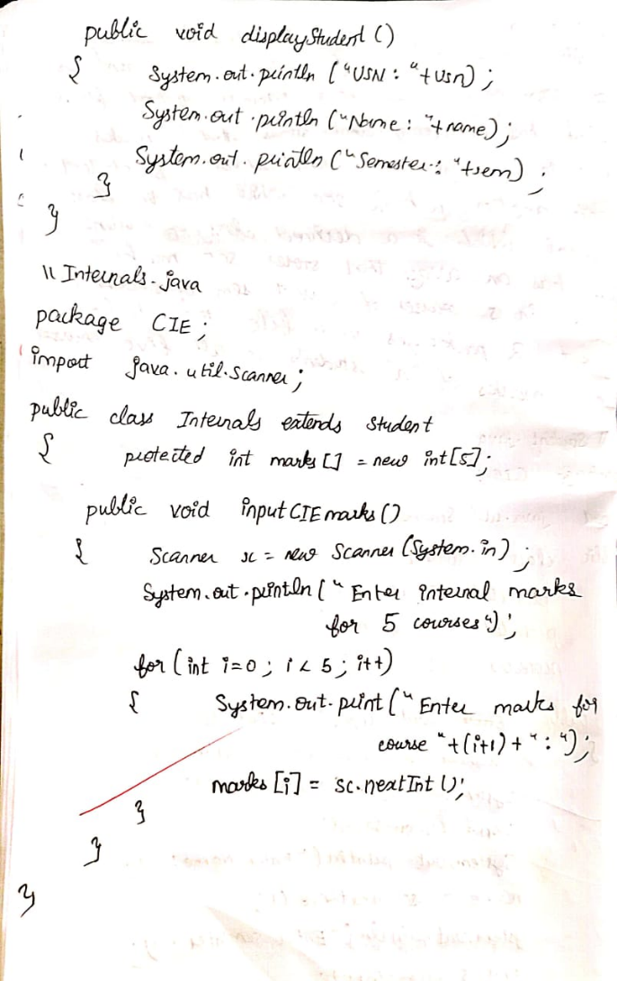

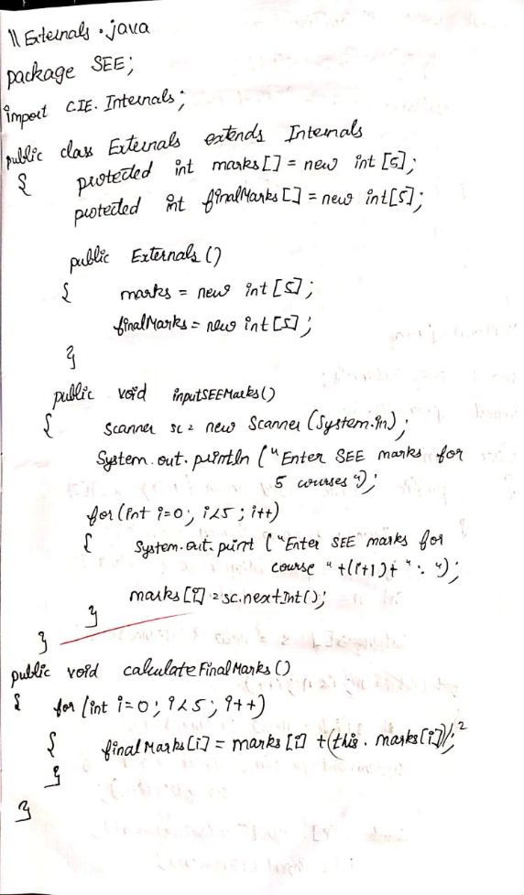 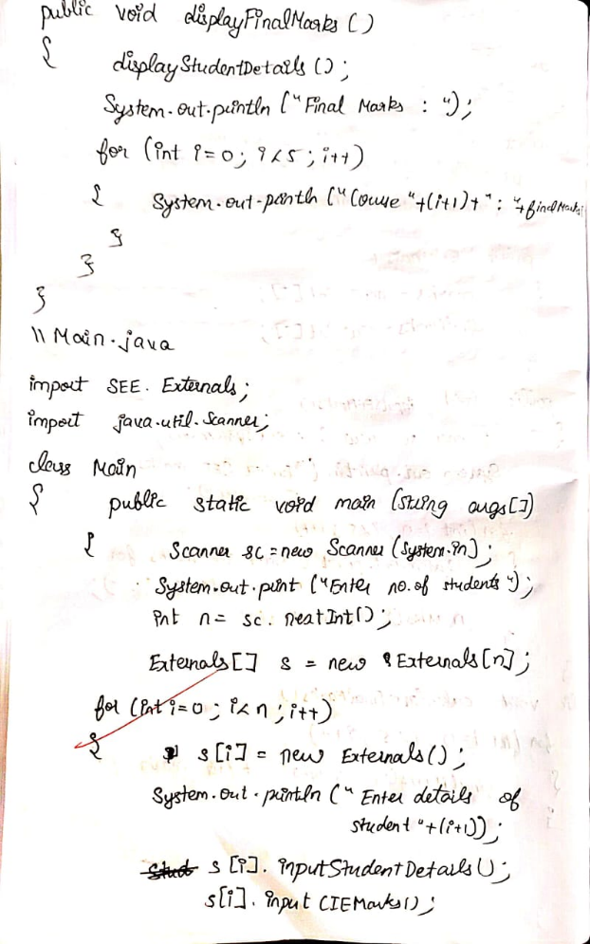

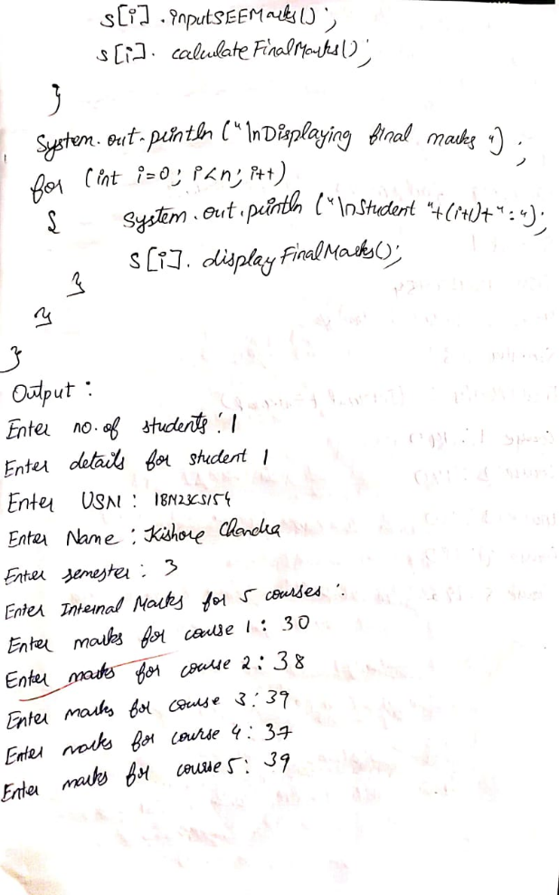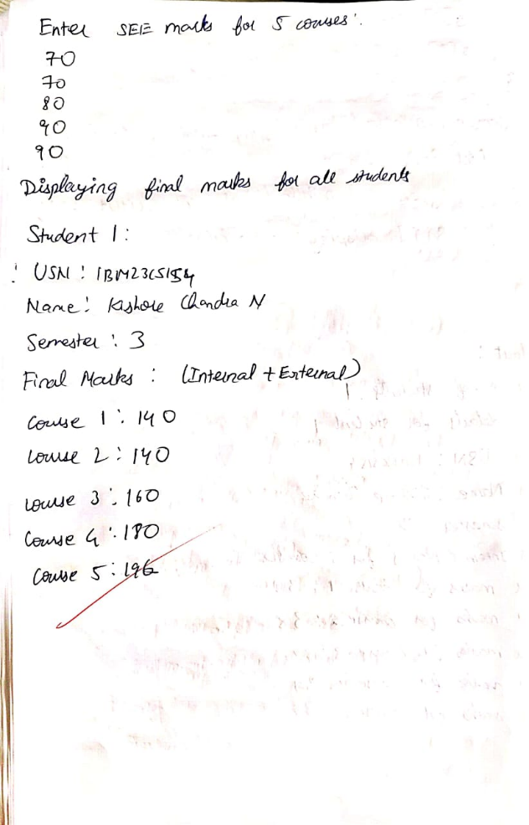

Code:

package SEE;

import CIE.Internals;

import java.util.Scanner;

public class Externals extends Internals {

protected int marks[] = new int[5];

protected int finalMarks[] = new int[5];

public Externals() {

marks = new int[5];

finalMarks = new int[5];

}

public void inputSEEmarks() {

Scanner s = new Scanner(System.in);

System.out.println("Enter SEE Marks for 5 courses:");

for (int i = 0; i < 5; i++) {

System.out.print("Enter SEE marks for course " + (i + 1) + ": ");

marks[i] = s.nextInt();

}

}

public void calculateFinalMarks() {

for (int i = 0; i < 5; i++) {

finalMarks[i] = marks[i] + this.marks[i];

}

}

public void displayFinalMarks() {

displayStudentDetails();

System.out.println("Final Marks (Internal + External):");

for (int i = 0; i < 5; i++) {

System.out.println("Course " + (i + 1) + ": " + finalMarks[i]);

}

}

}

package CIE;

import java.util.Scanner;

public class Internals extends Student {

protected int marks[] = new int[5];

public void inputCIEmarks() {

Scanner s = new Scanner(System.in);

System.out.println("Enter Internal Marks for 5 courses:");

for (int i = 0; i < 5; i++) {

System.out.print("Enter marks for course " + (i + 1) + ": ");

marks[i] = s.nextInt();

}

}

}

package CIE;

import java.util.Scanner;

public class Student {

protected String usn;

protected String name;

protected int sem;

public void inputStudentDetails() {

Scanner s = new Scanner(System.in);

System.out.print("Enter USN: ");

usn = s.nextLine();

System.out.print("Enter Name: ");

name = s.nextLine();

System.out.print("Enter Semester: ");

sem = s.nextInt();

}

public void displayStudentDetails() {

System.out.println("USN: " + usn);

System.out.println("Name: " + name);

System.out.println("Semester: " + sem);

}

}

import SEE.Externals;

import java.util.Scanner;

class Main {

public static void main(String[] args) {

Scanner scanner = new Scanner(System.in);

System.out.print("Enter the number of students: ");

int n = scanner.nextInt();

Externals[] students = new Externals[n];

for (int i = 0; i < n; i++) {

students[i] = new Externals();

System.out.println("\nEnter details for student " + (i + 1));

students[i].inputStudentDetails();

students[i].inputCIEmarks();

students[i].inputSEEmarks();

students[i].calculateFinalMarks();

}

System.out.println("\nDisplaying final marks for all students:");

for (int i = 0; i < n; i++) {

System.out.println("\nStudent " + (i + 1) + ":");

students[i].displayFinalMarks();

}

}

}

Output:

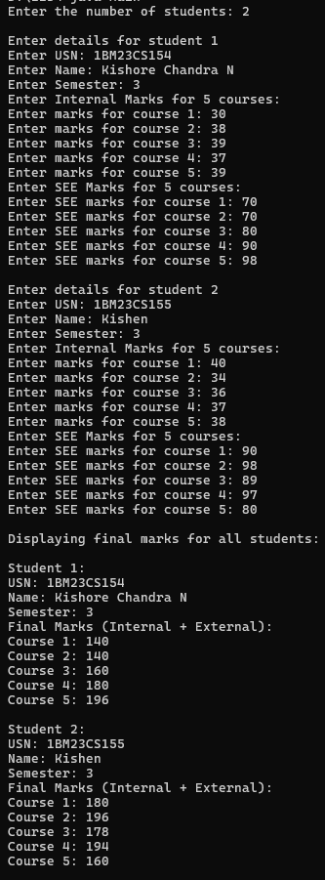

**Program 7**

Write a program that demonstrates handling of exceptions in inheritance tree. Create a base class called “Father” and derived class called “Son” which extends the base class. In Father class, implement a constructor which takes the age and throws the exception WrongAge( ) when the input age<0. In Son class, implement a constructor that uses both father and son’s age and throws an exception if son’s age is >=father’s age.

Algorithm:

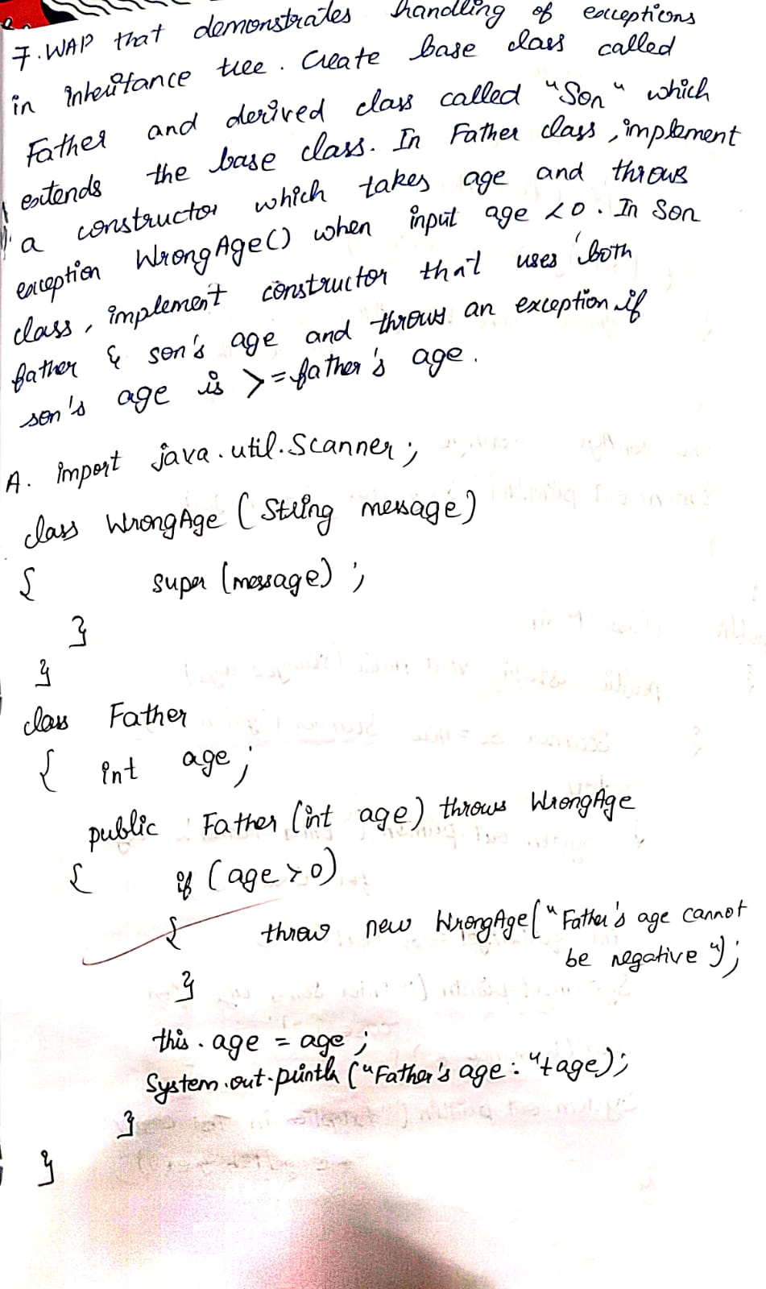 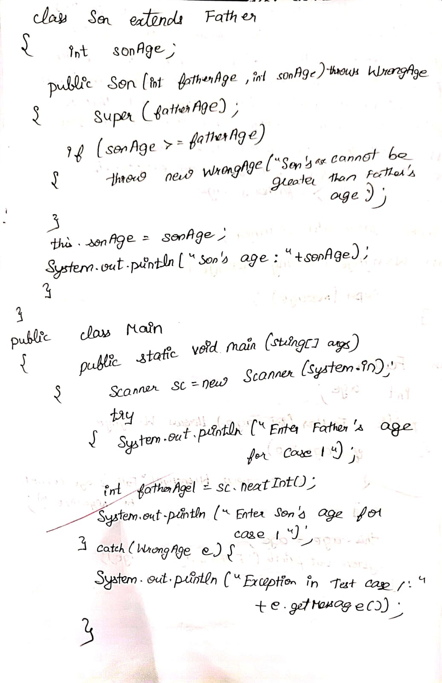

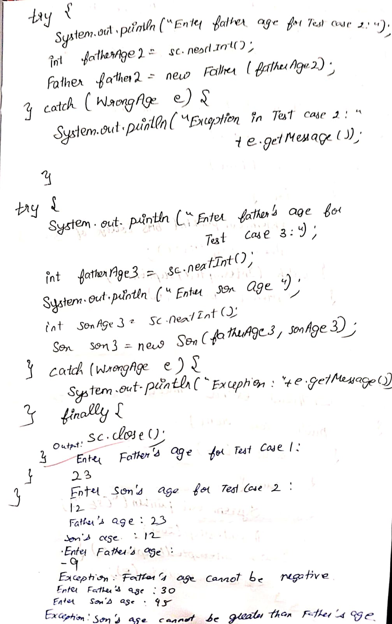

Code:

import java.util.Scanner;

class WrongAge extends Exception {

public WrongAge(String message) {

super(message);

}

}

class Father {

int age;

public Father(int age) throws WrongAge {

if (age < 0) {

throw new WrongAge("Father's age cannot be negative.");

}

this.age = age;

System.out.println("Father's age: " + age);

}

}

class Son extends Father {

int sonAge;

public Son(int fatherAge, int sonAge) throws WrongAge {

super(fatherAge);

if (sonAge >= fatherAge) {

throw new WrongAge("Son's age cannot be greater than or equal to Father's age.");

}

this.sonAge = sonAge;

System.out.println("Son's age: " + sonAge);

}

}

public class Main {

public static void main(String[] args) {

Scanner scanner = new Scanner(System.in);

try {

System.out.println("Enter Father's age for Test Case 1:");

int fatherAge1 = scanner.nextInt();

System.out.println("Enter Son's age for Test Case 1:");

int sonAge1 = scanner.nextInt();

Son son1 = new Son(fatherAge1, sonAge1);

} catch (WrongAge e) {

System.out.println("Exception in Test Case 1: " + e.getMessage());

}

try {

System.out.println("\nEnter Father's age for Test Case 2:");

int fatherAge2 = scanner.nextInt();

Father father2 = new Father(fatherAge2);

} catch (WrongAge e) {

System.out.println("Exception in Test Case 2: " + e.getMessage());

}

try {

System.out.println("\nEnter Father's age for Test Case 3:");

int fatherAge3 = scanner.nextInt();

System.out.println("Enter Son's age for Test Case 3:");

int sonAge3 = scanner.nextInt();

Son son2 = new Son(fatherAge3, sonAge3);

} catch (WrongAge e) {

System.out.println("Exception in Test Case 3: " + e.getMessage());

} finally {

scanner.close();

}

}

}

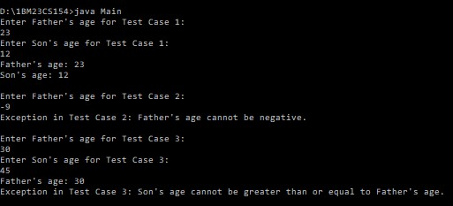

**Program 8**

Write a program which creates two threads, one thread displaying “BMS College of Engineering” once every ten seconds and another displaying “CSE” once every two seconds.

Algorithm

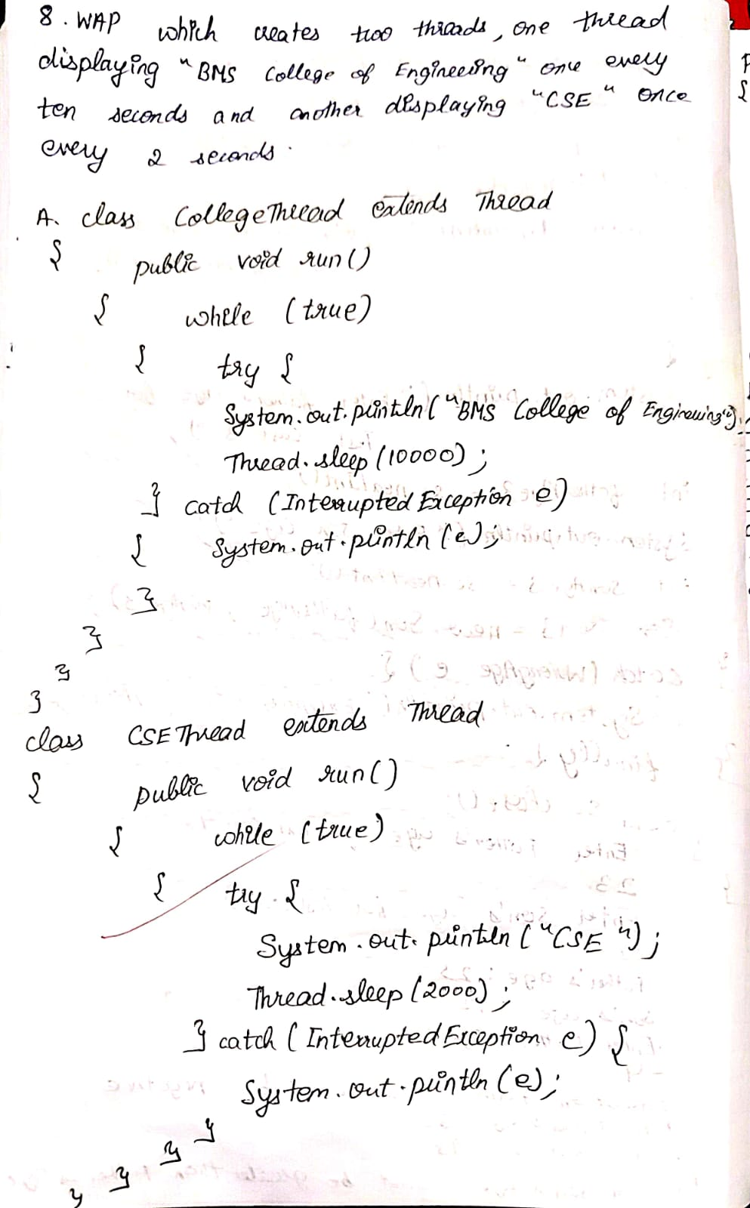 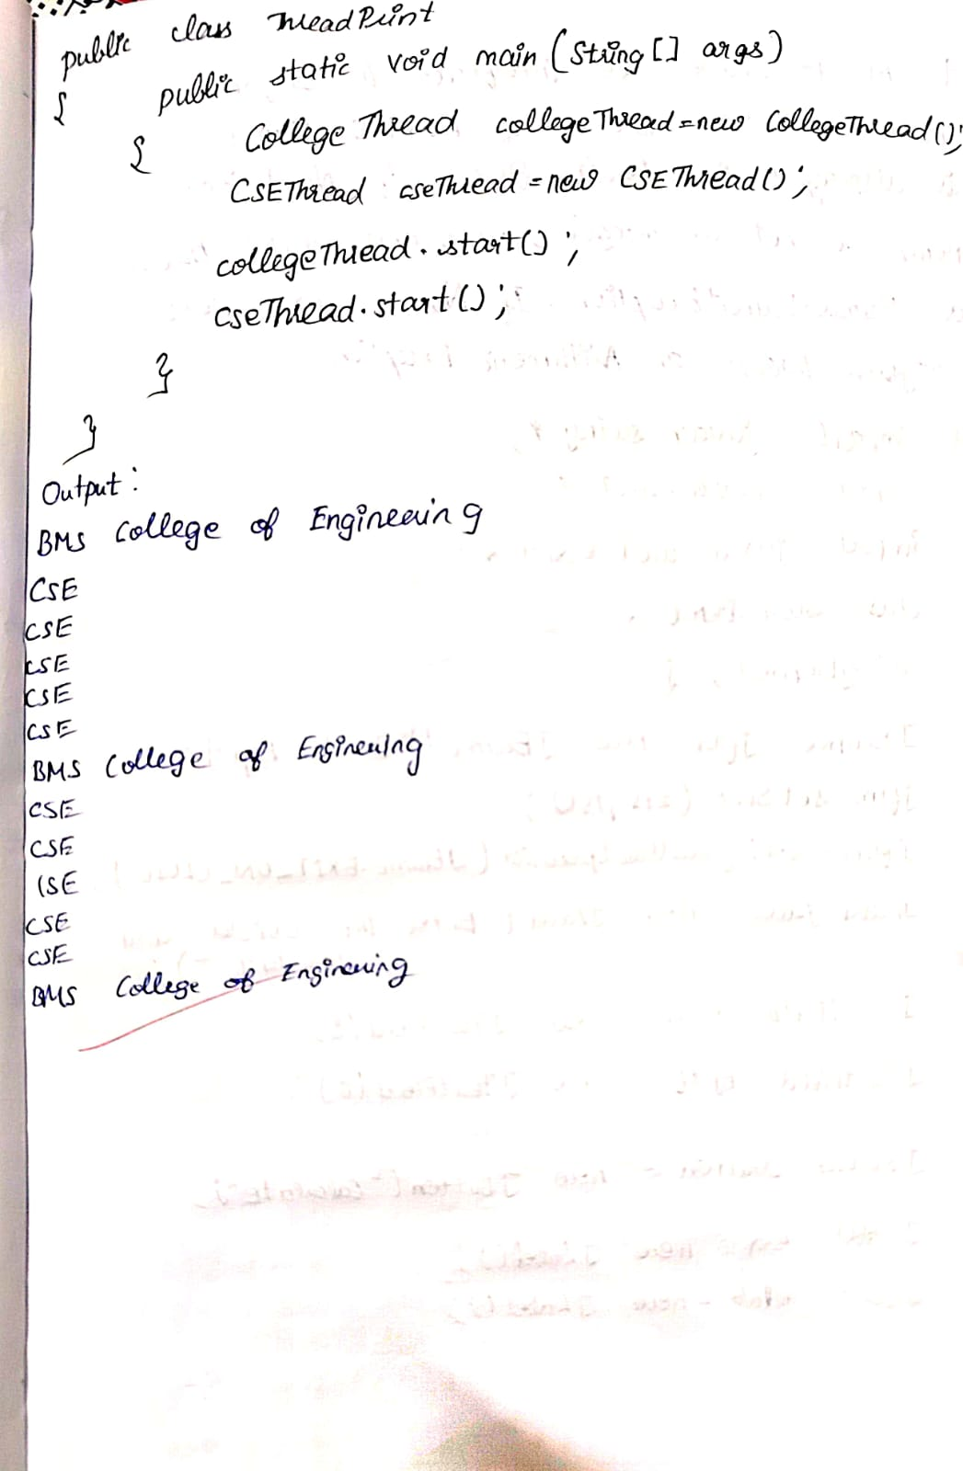

Code:

class CollegeThread extends Thread {

public void main{

while (true) {

try {

System.out.println("BMS College of Engineering");

Thread.sleep(10000);

} catch (InterruptedException e) {

System.out.println(e);

}

}

}

}

class CSEThread extends Thread {

public void run() {

while (true) {

try {

System.out.println("CSE");

Thread.sleep(2000);

} catch (InterruptedException e) {

System.out.println(e);

}

}

}

}

public class ThreadPrint {

public static void main(String[] args) {

CollegeThread collegeThread = new CollegeThread();

CSEThread cseThread = new CSEThread();

collegeThread.start();

cseThread.start();

}

}

Output:

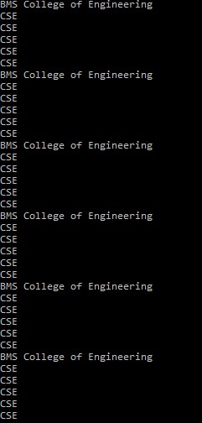

**Program 9**

Write a program that creates a user interface to perform integer divisions. The user enters two numbers in the text fields, Num1 and Num2. The division of Num1 and Num2 is displayed in the Result field when the Divide button is clicked. If Num1 or Num2 were not an integer, the program would throw a NumberFormatException. If Num2 were Zero, the program would throw an Arithmetic Exception Display the exception in a message dialog box.

Algorithm:

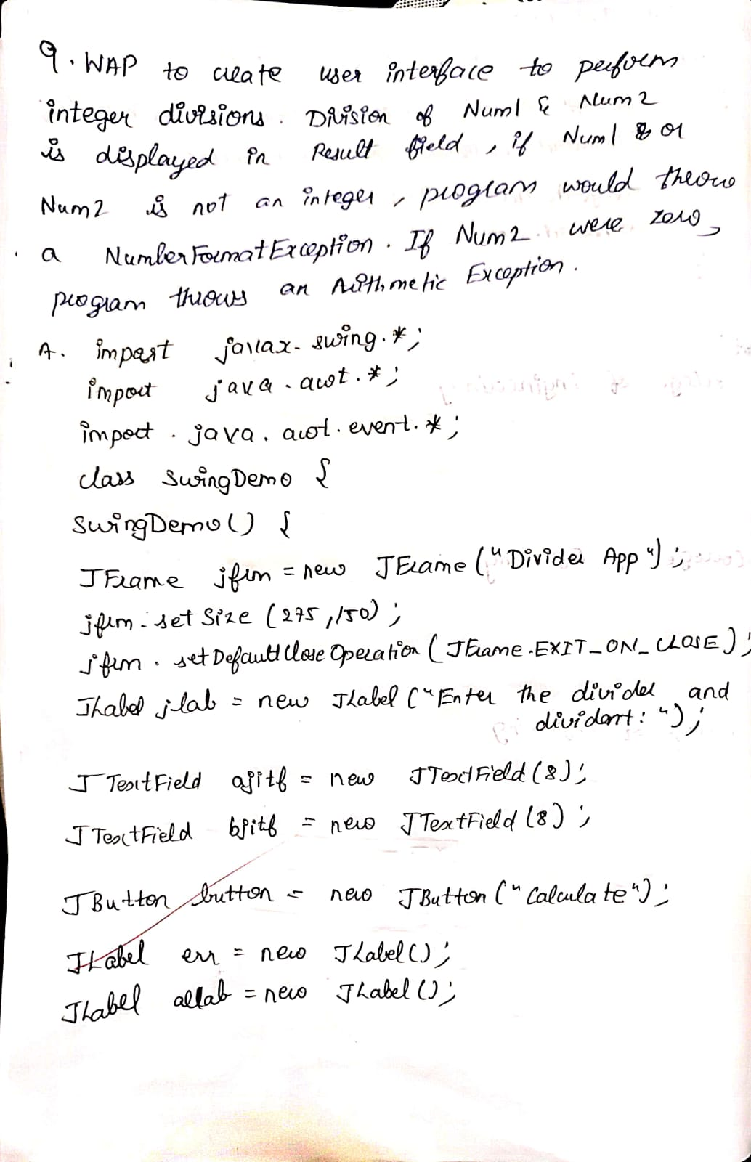 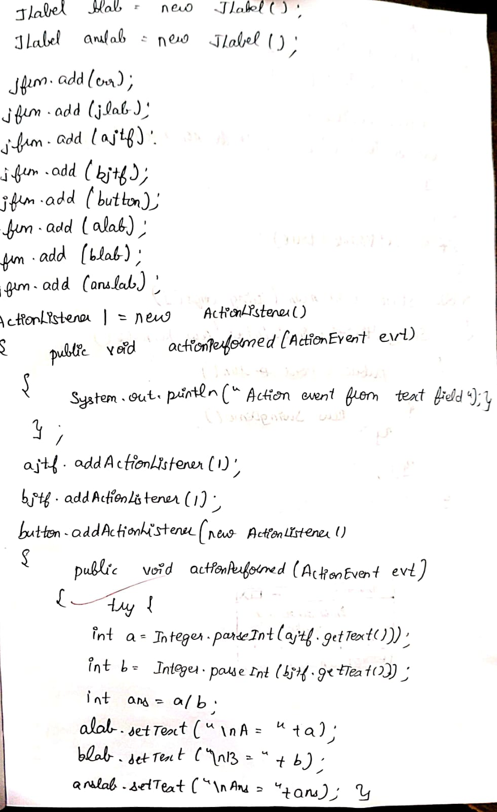

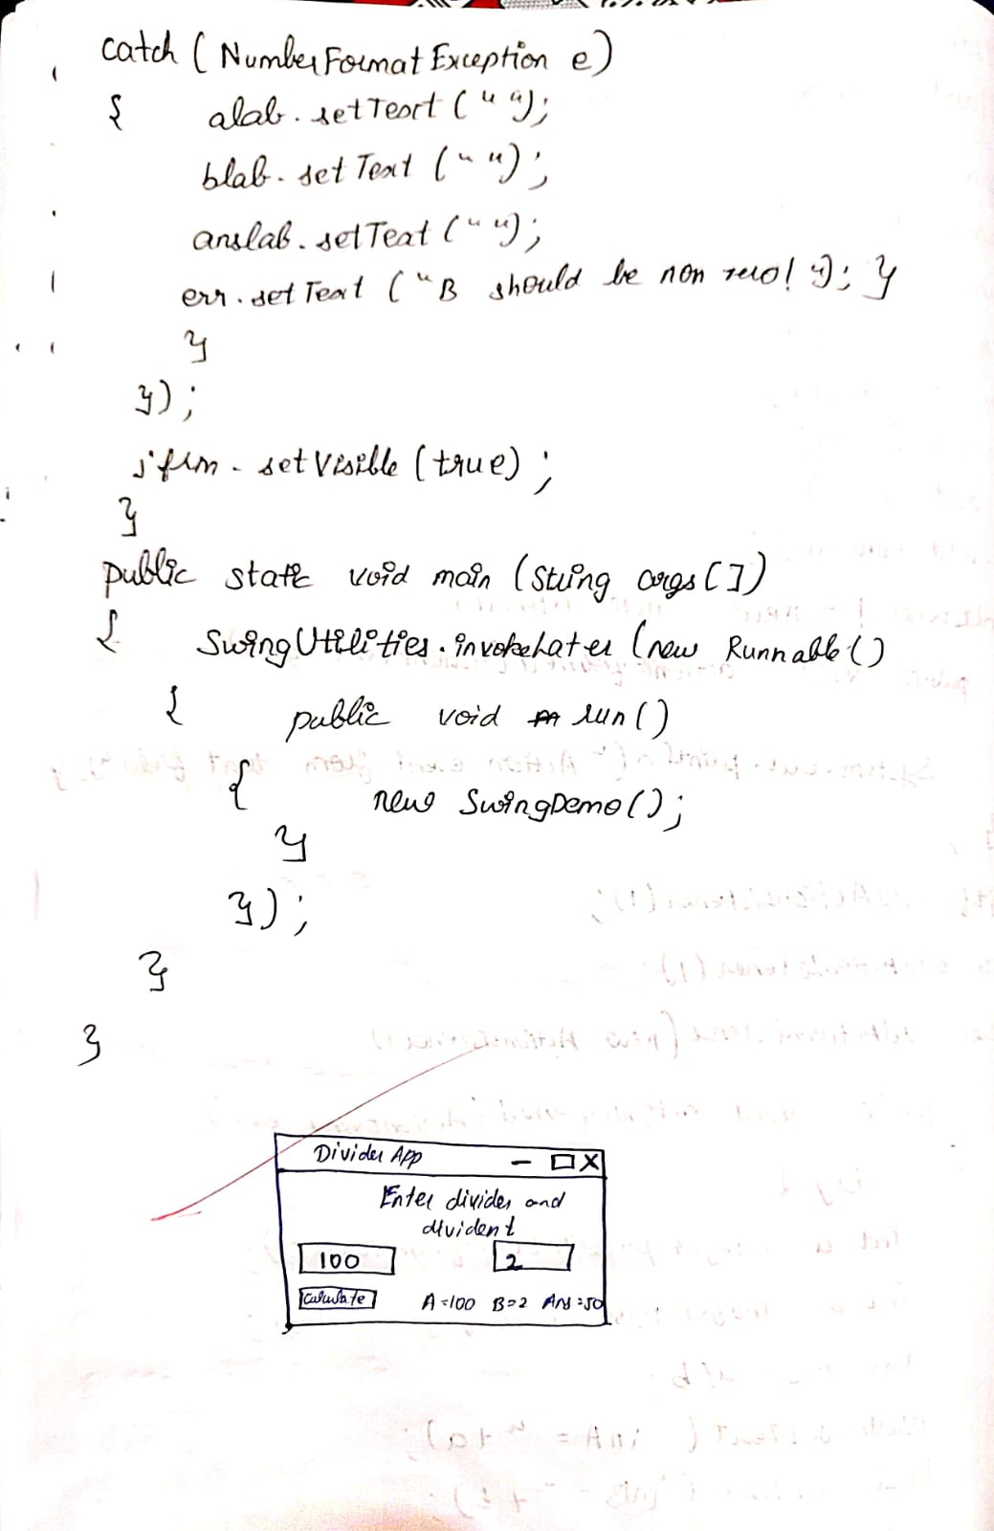

Code:

import javax.swing.*;

import java.awt.*;

import java.awt.event.*;

class SwingDemo{

SwingDemo(){

// create jframe container

JFrame jfrm = new JFrame("Divider App");

jfrm.setSize(275, 150);

jfrm.setLayout(new FlowLayout());

// to terminate on close

jfrm.setDefaultCloseOperation(JFrame.EXIT_ON_CLOSE);

// text label

JLabel jlab = new JLabel("Enter the divider and divident:");

// add text field for both numbers

JTextField ajtf = new JTextField(8);

JTextField bjtf = new JTextField(8);

// calc button

JButton button = new JButton("Calculate");

// labels

JLabel err = new JLabel();

JLabel alab = new JLabel();

JLabel blab = new JLabel();

JLabel anslab = new JLabel();

// add in order :)

jfrm.add(err); // to display error bois

jfrm.add(jlab);

jfrm.add(ajtf);

jfrm.add(bjtf);

jfrm.add(button);

jfrm.add(alab);

jfrm.add(blab);

jfrm.add(anslab);

ActionListener l = new ActionListener() {

public void actionPerformed(ActionEvent evt) {

System.out.println("Action event from a text field"); }

};

ajtf.addActionListener(l);

bjtf.addActionListener(l);

button.addActionListener(new ActionListener() {

public void actionPerformed(ActionEvent evt) { try{

int a = Integer.parseInt(ajtf.getText()); int b =

Integer.parseInt(bjtf.getText()); int ans = a/b;

alab.setText("\nA = " + a);

blab.setText("\nB = " + b);

anslab.setText("\nAns = "+ ans);

}

catch(NumberFormatException e){

alab.setText("");

blab.setText("");

anslab.setText("");

err.setText("Enter Only Integers!"); }

catch(ArithmeticException e){

alab.setText("");

blab.setText("");

anslab.setText("");

err.setText("B should be NON zero!"); }

}

});

// display frame

jfrm.setVisible(true);

}

public static void main(String args[]){ // create frame on event dispatching thread

SwingUtilities.invokeLater(new Runnable(){

public void run(){

new SwingDemo();

}

});

}

}

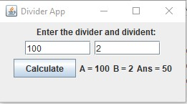

**Program 10**

Demonstrate Inter process Communication and deadlock

Algorithm:

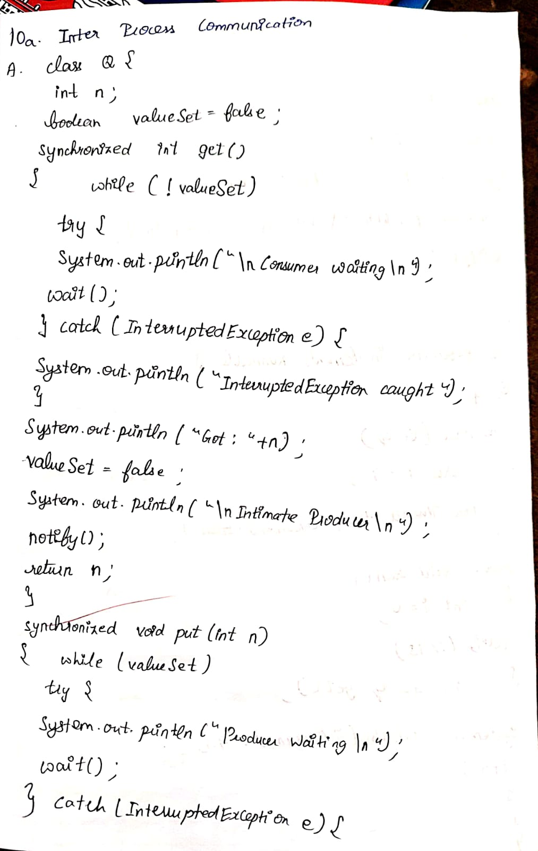 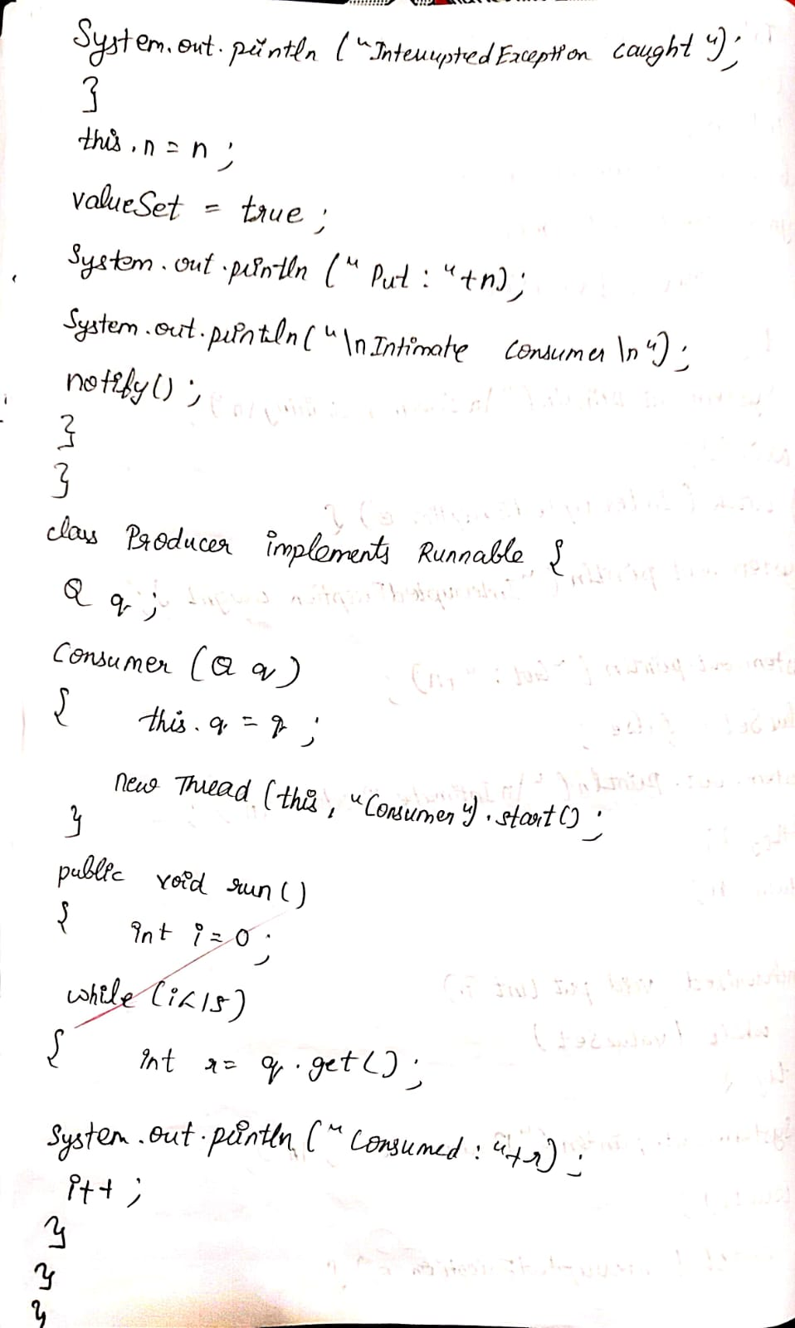

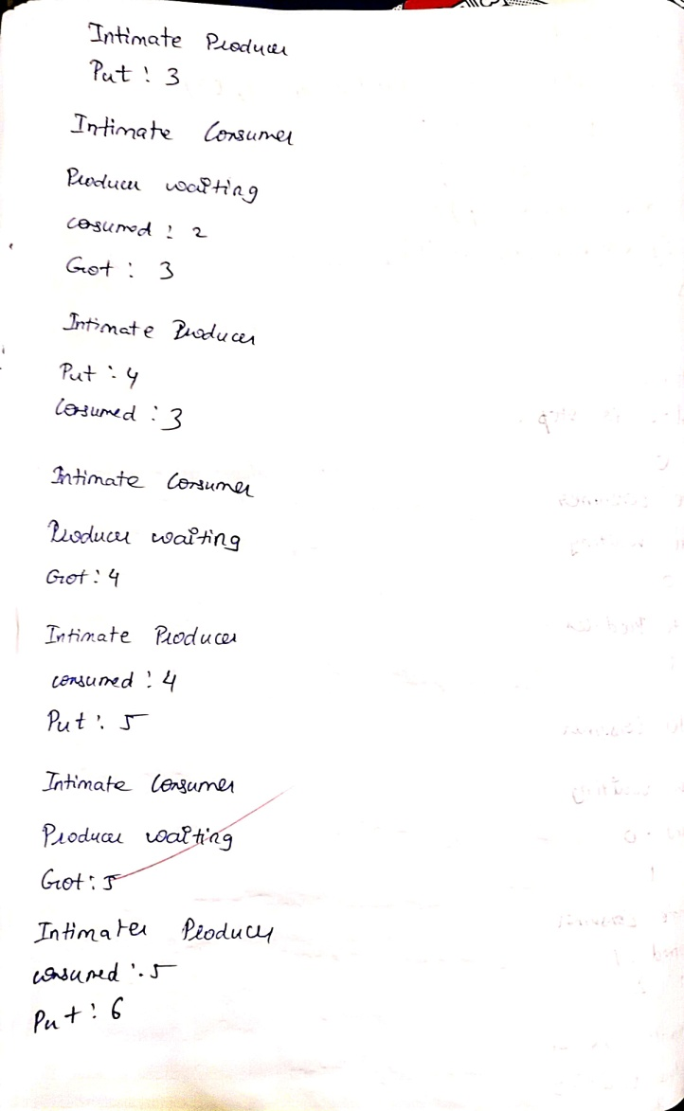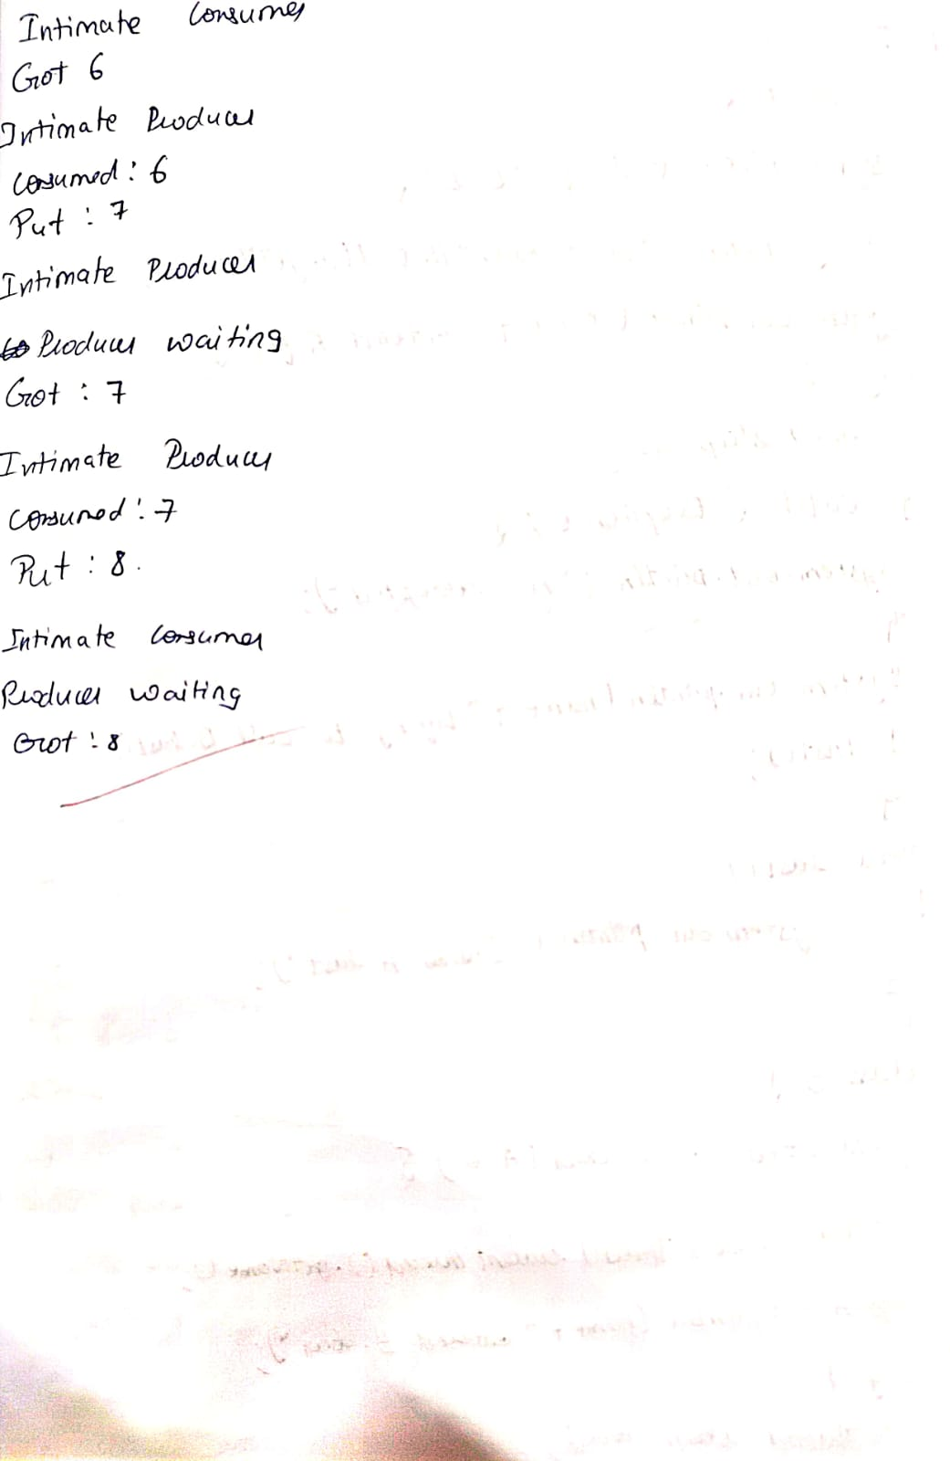

Code:

class Q {

int n;

boolean valueSet = false;

synchronized int get() {

while(!valueSet)

try {

System.out.println("\nConsumer waiting\n");

wait();

} catch(InterruptedException e) {

System.out.println("InterruptedException caught");

}

System.out.println("Got: " + n);

valueSet = false;

System.out.println("\nIntimate Producer\n");

notify();

return n;

}

synchronized void put(int n) {

while(valueSet)

try {

System.out.println("\nProducer waiting\n");

wait();

} catch(InterruptedException e) {

System.out.println("InterruptedException caught");

}

this.n = n;

valueSet = true;

System.out.println("Put: " + n);

System.out.println("\nIntimate Consumer\n");

notify();

} }

class Producer implements Runnable {

Q q;

Producer(Q q) {

this.q = q;

new Thread(this, "Producer").start();

}

public void run() {

int i = 0;

while(i<15) {

q.put(i++);

} } }

class Consumer implements Runnable {

Q q;

Consumer(Q q) {

this.q = q;

new Thread(this, "Consumer").start();

}

public void run() {

int i=0;

while(i<15) {

int r=q.get();

System.out.println("consumed:"+r);

i++;

} } }

class PCFixed {

public static void main(String args[]) {

Q q = new Q();

new Producer(q);

new Consumer(q);

System.out.println("Press Control-C to stop.");

} }

Output:

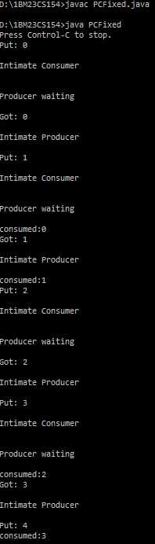 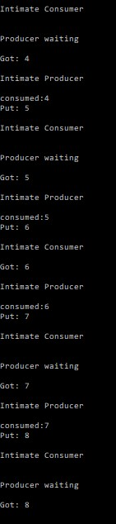

**Deadlock**

Algorithm:

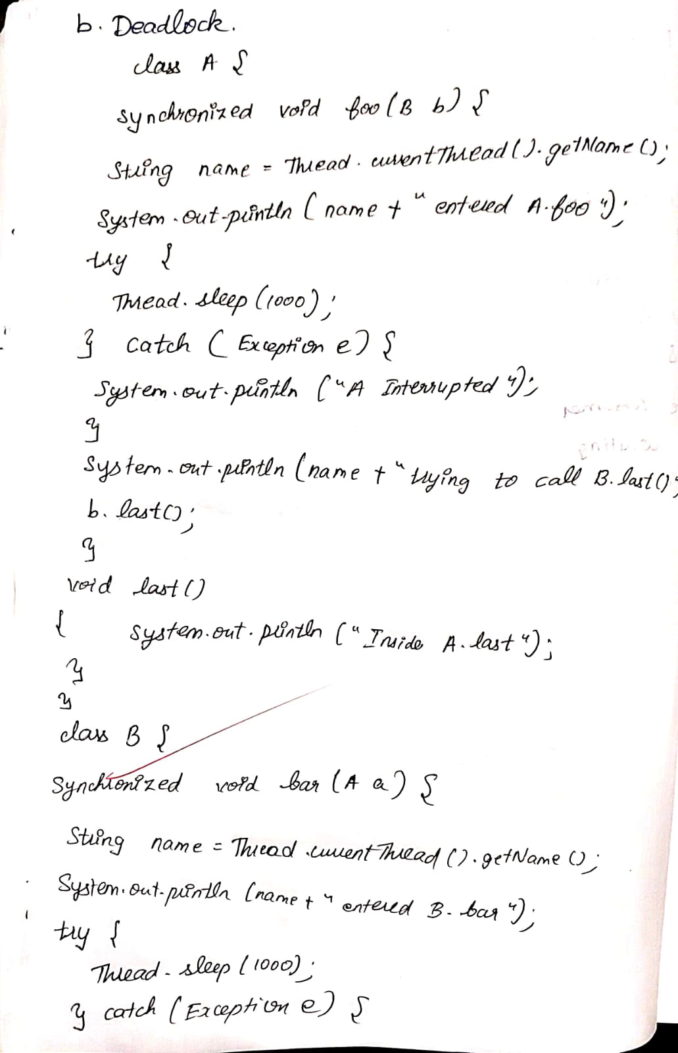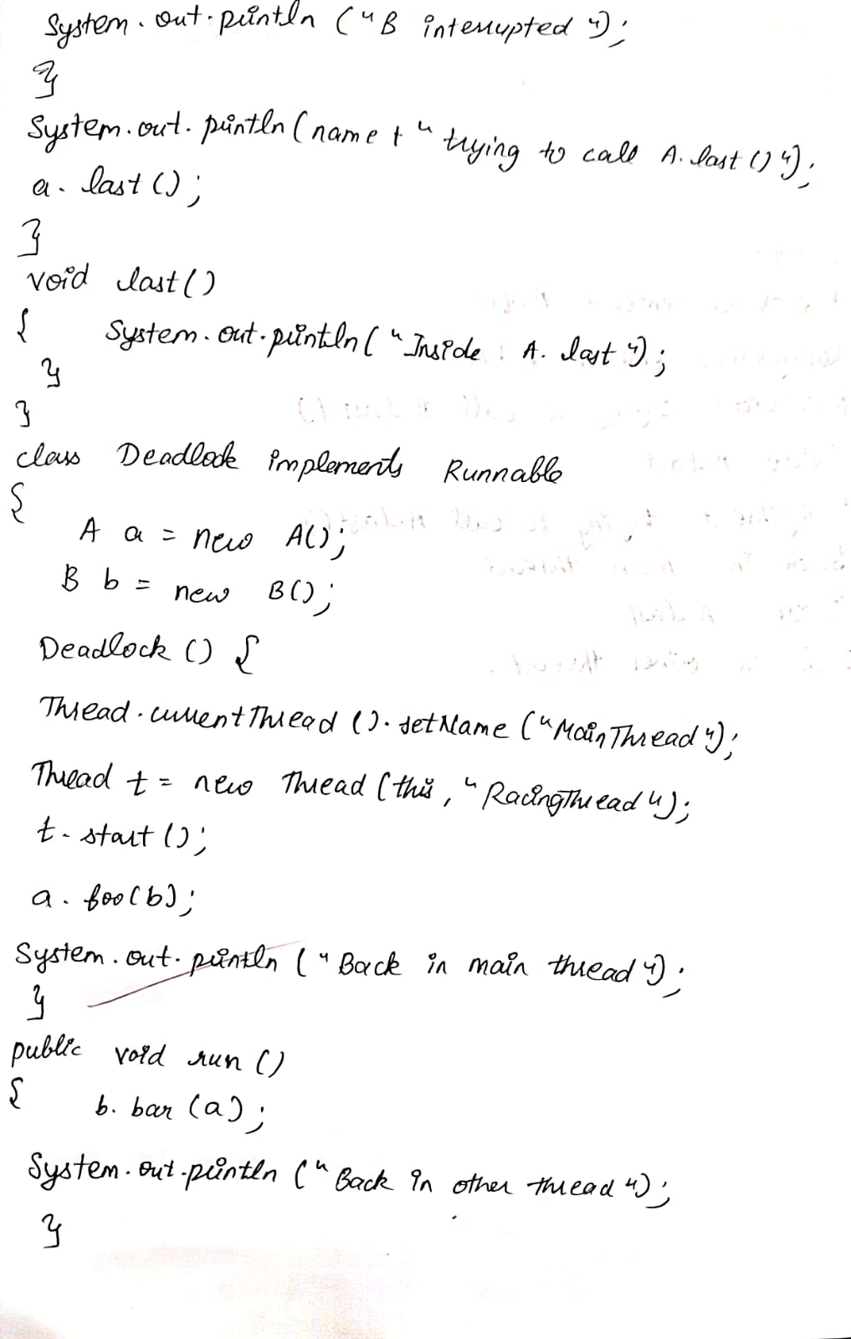

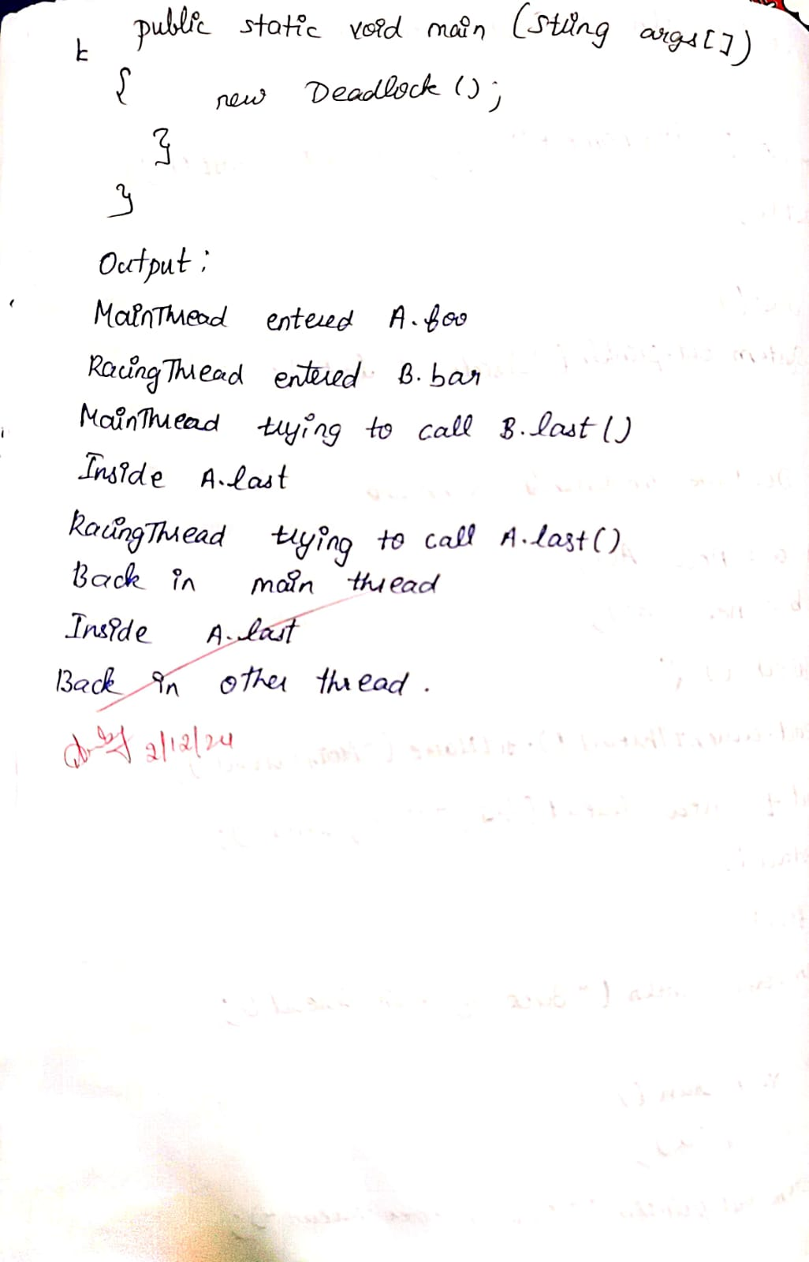

Code:

class A {

synchronized void foo(B b) {

String name =Thread.currentThread().getName();

System.out.println(name + " entered A.foo");

try {

Thread.sleep(1000);

} catch(Exception e) {

System.out.println("A Interrupted");

}

System.out.println(name + " trying to call B.last()");

b.last();

}

void last() {

System.out.println("Inside A.last");

}

}

class B {

synchronized void bar(A a) {

String name =Thread.currentThread().getName();

System.out.println(name + " entered B.bar");

try {

Thread.sleep(1000);

} catch(Exception e) {

System.out.println("B Interrupted");

}

System.out.println(name + " trying to call A.last()");

a.last();

}

void last() {

System.out.println("Inside A.last");

}

}

class Deadlock implements Runnable

{

A a = new A();

B b = new B();

Deadlock() {

Thread.currentThread().setName("MainThread");

Thread t = new Thread(this,"RacingThread");

t.start();

a.foo(b); // get lock on a in this thread.

System.out.println("Back in main thread");

}

public void run() {

b.bar(a);

System.out.println("Back in other thread");

}

public static void main(String args[]) {

new Deadlock();

}

}

